

**Evidence Gathering Document for SQA Level 8 Professional Developer Award.**

This document is designed for you to present your screenshots and diagrams relevant to the PDA and to also give a short description of what you are showing to clarify understanding for the assessor.

Each point that required details the Assessment Criteria (What you have to show) along with a brief description of the kind of things you should be showing.

Please fill in each point with screenshot or diagram and description.

**Week 2**

|  |  |  |  |
| --- | --- | --- | --- |
| **Unit** | **Ref** | **Evidence** |  |
| **I&T** | I.T.5 | Demonstrate the use of an array in a program. Take screenshots of:  *An array in a program  *A function that uses the array  *The result of the function running | |

**Paste Screenshot here**

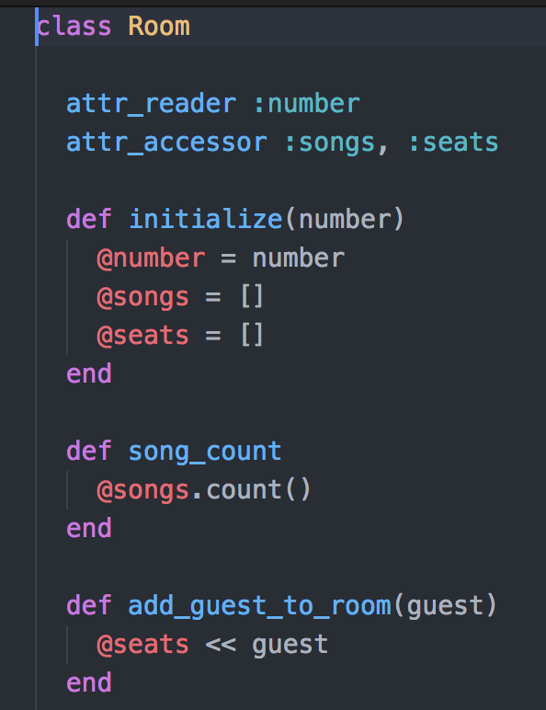

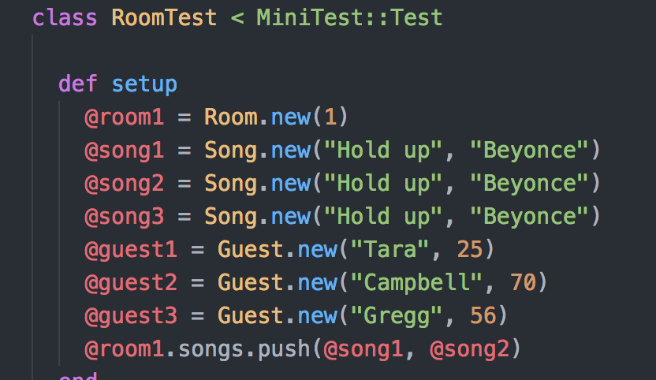

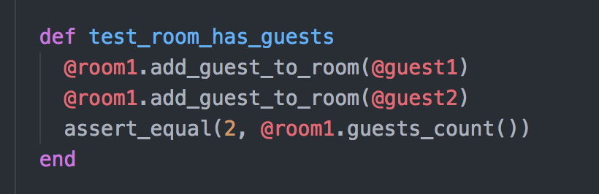

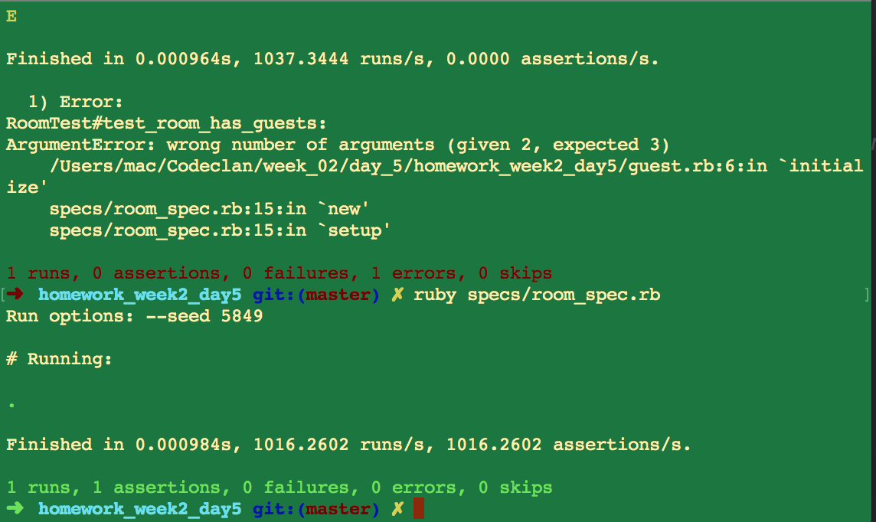

**Description here**

The first screenshot shows room which is set up to have an empty array of guests in its constructor and the method which will add guests to that array. The second shows the set up for a test before we add some guests to a room. The third shows the function in action and the last screenshot shows the test passing after we have counted that the guest objects have successfully been put in the room’s guest array.

|  |  |  |  |
| --- | --- | --- | --- |
| **Unit** | **Ref** | **Evidence** |  |
| **I&T** | I.T.6 | Demonstrate the use of a hash in a program. Take screenshots of:  *A hash in a program  *A function that uses the hash  *The result of the function running | |

**Paste Screenshot here**

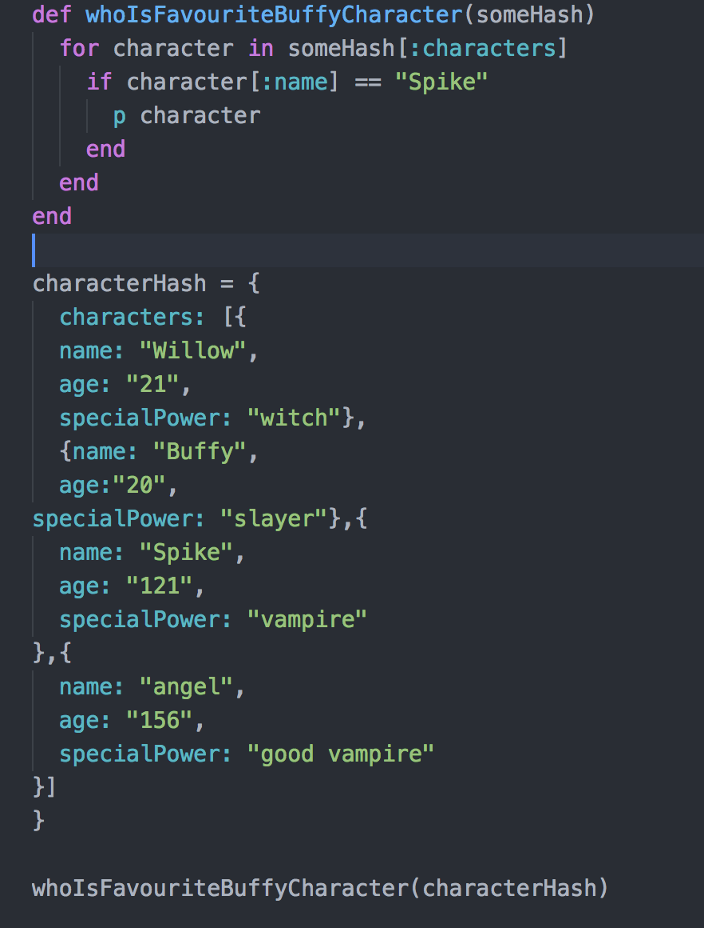

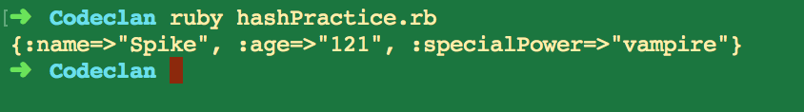

**Description here**

In the first screenshot we have a hash I made for Buffy the Vampire Slayer characters and a function which brings back the character Spike as the favourite character. In the second we have the result of running that function on the hash, which successfully brings back the favourite character as Spike.

**Week 3**

|  |  |  |  |
| --- | --- | --- | --- |
| **Unit** | **Ref** | **Evidence** |  |
| **I&T** | I.T.3 | Demonstrate searching data in a program. Take screenshots of:  *Function that searches data  *The result of the function running | |

**Paste Screenshot here**

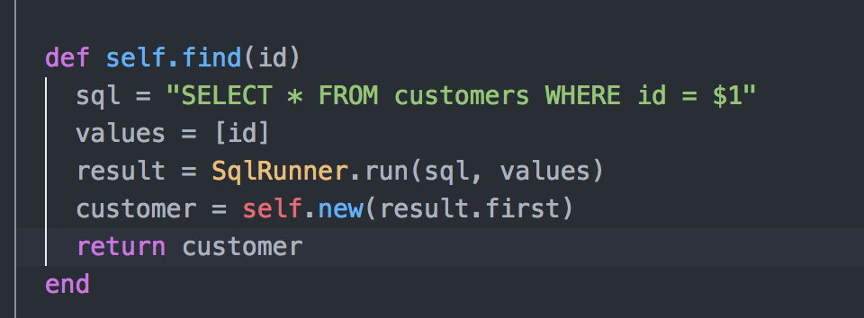

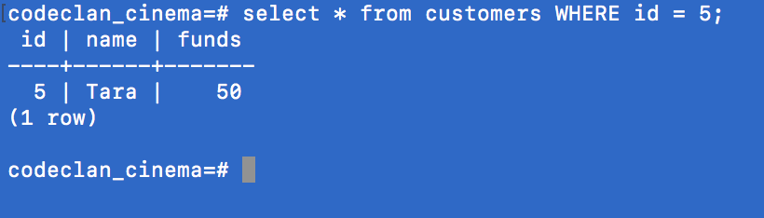

**Description here**

In the first screenshot, you can see my method to find a customer by id and in the second you can see the result of that method successfully finding a customer by their id.

|  |  |  |  |
| --- | --- | --- | --- |
| **Unit** | **Ref** | **Evidence** |  |
| **I&T** | I.T.4 | Demonstrate sorting data in a program. Take screenshots of:  *Function that sorts data  *The result of the function running | |

**Paste Screenshot here**

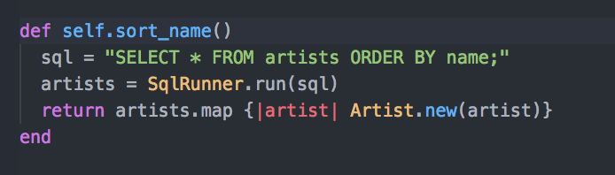

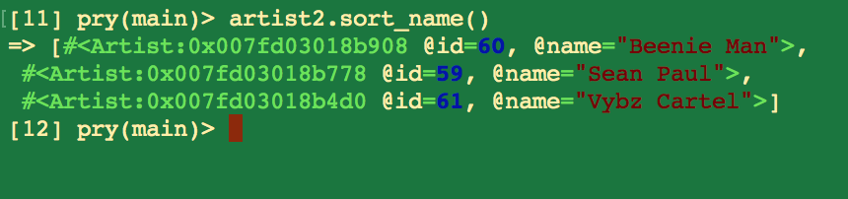

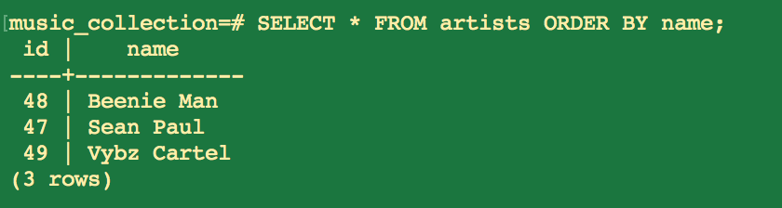

**Description here**

In the first screenshot, there is the method which sorts artist names in the database into alphabetical order. In the second and third screenshots, you can see the result of this method successfully sorting artists by the order of their names.

**Week 5**

|  |  |  |  |
| --- | --- | --- | --- |
| **Unit** | **Ref** | **Evidence** |  |
| **A&D** | A.D.1 | A Use Case Diagram | |

**Paste Screenshot here**

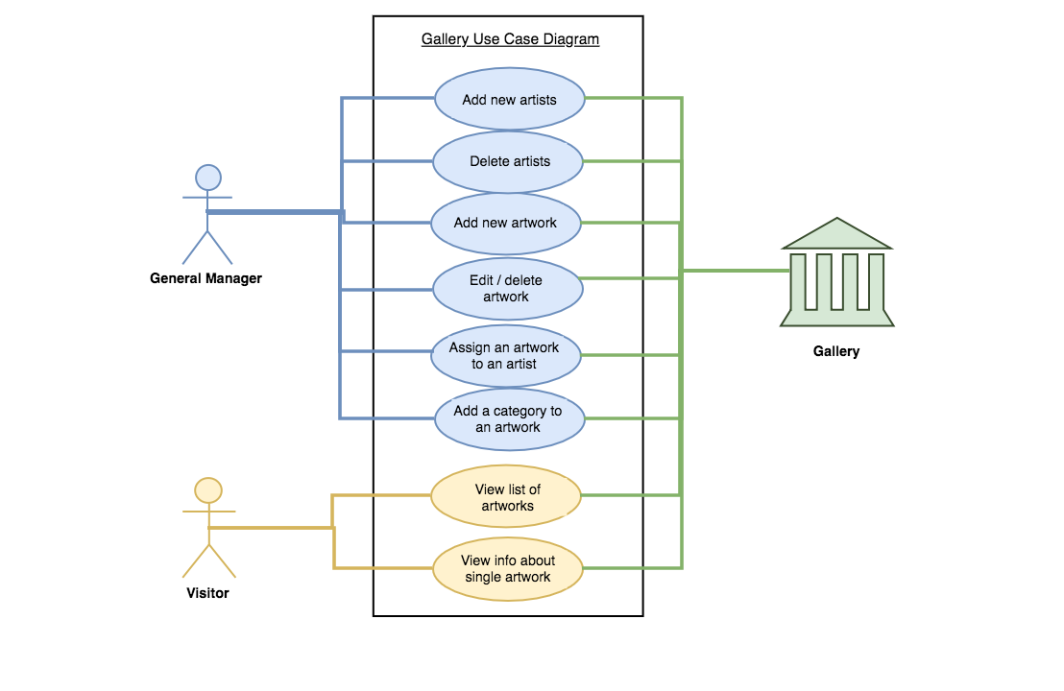

**Description here**

This is a use case diagram which demonstrates which functions are intended for which type of user. Here the general manager of my gallery web app has access to the bulk of the app’s functionality with the visitor having some basic functions too.

|  |  |  |  |
| --- | --- | --- | --- |
| **Unit** | **Ref** | **Evidence** |  |
| **A&D** | A.D.2 | A Class Diagram | |

**Paste Screenshot here**

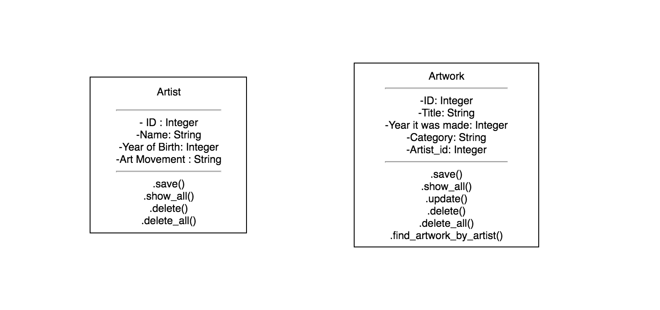

**Description here**

This is an example of a class diagram for a program which has two classes: one for artists and one for artworks. Their properties and methods are listed below.

|  |  |  |  |
| --- | --- | --- | --- |
| **Unit** | **Ref** | **Evidence** |  |
| **A&D** | A.D.3 | An Object Diagram | |

**Paste Screenshot here**

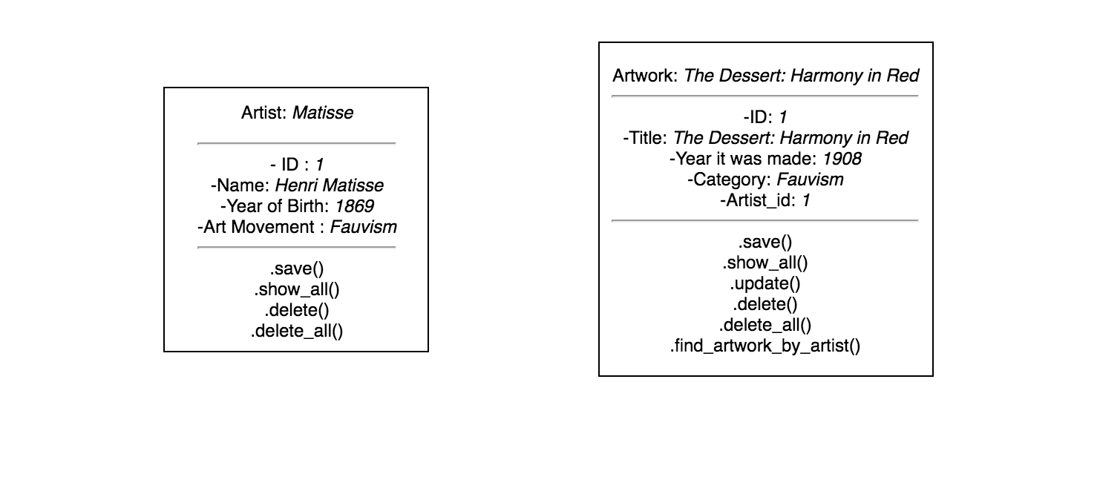

**Description here**

Here is an object diagram, which lays out examples of properties for each class of Artist and Artwork.

|  |  |  |  |
| --- | --- | --- | --- |
| **Unit** | **Ref** | **Evidence** |  |
| **A&D** | A.D.4 | An Activity Diagram | |

**Paste Screenshot here**

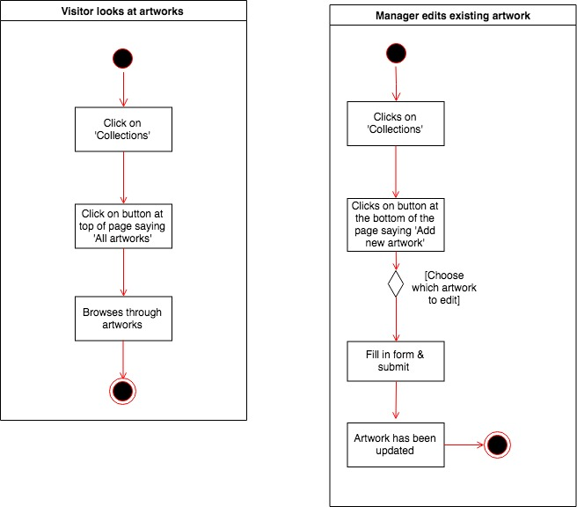

**Description here**

These are two activity diagrams for my gallery app, which show examples of interactions for the visitor and the manager. The visitor for example, can browse through the list of artworks a gallery has and the manager can add new artworks to the gallery’s collection.

|  |  |  |  |
| --- | --- | --- | --- |
| **Unit** | **Ref** | **Evidence** |  |
| **A&D** | A.D.6 | Produce an Implementations Constraints plan detailing the following factors:  *Hardware and software platforms  *Performance requirements  *Persistent storage and transactions  *Usability  *Budgets  *Time | |
|  |  |  | |

**Paste Screenshot here**

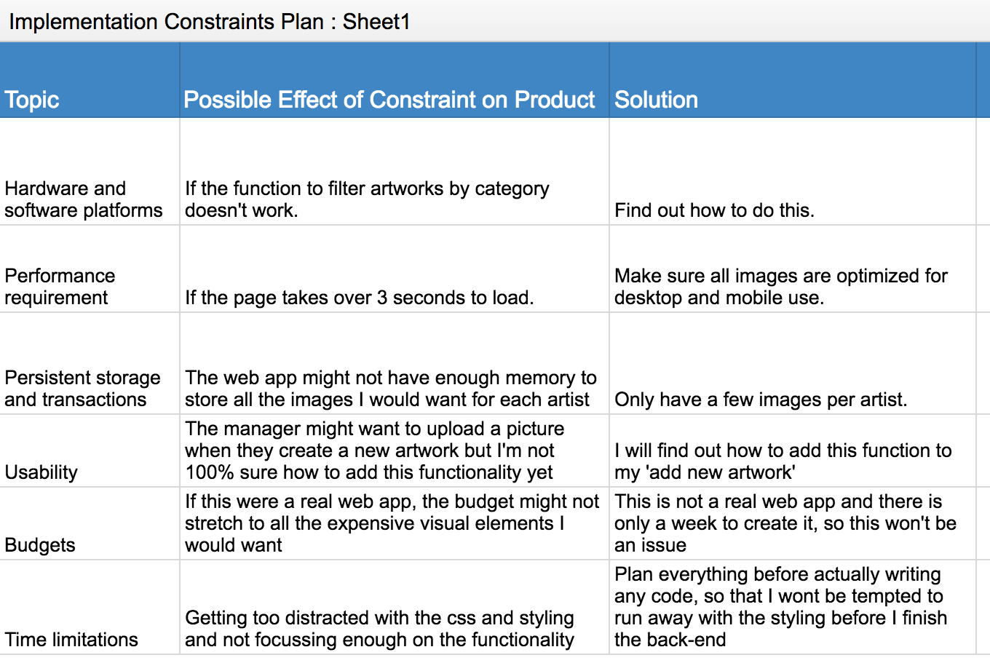

**Description here**

Here is an implementation constraints plan I made for my project. Some of the criteria were more useful than others, for example budget wasn’t really relevant this time and time limitations were particularly strict.

|  |  |  |  |
| --- | --- | --- | --- |
| **Unit** | **Ref** | **Evidence** |  |
| **P** | P.5 | User Site Map | |

**Paste Screenshot here**

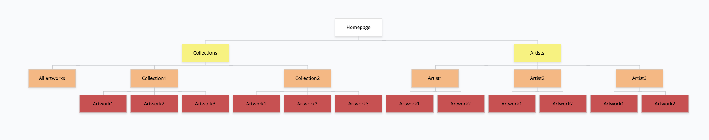

**Description here**

This is a sitemap of my art gallery web app. It has two main pages: collections and artists. You can visit a list of all artworks from the collections page and a list of all artists from the artists page. You can then further select individual artworks or individual artists from these pages.

|  |  |  |  |
| --- | --- | --- | --- |
| **Unit** | **Ref** | **Evidence** |  |
| **P** | P.6 | 2 Wireframe Diagrams | |

**Paste Screenshot here**

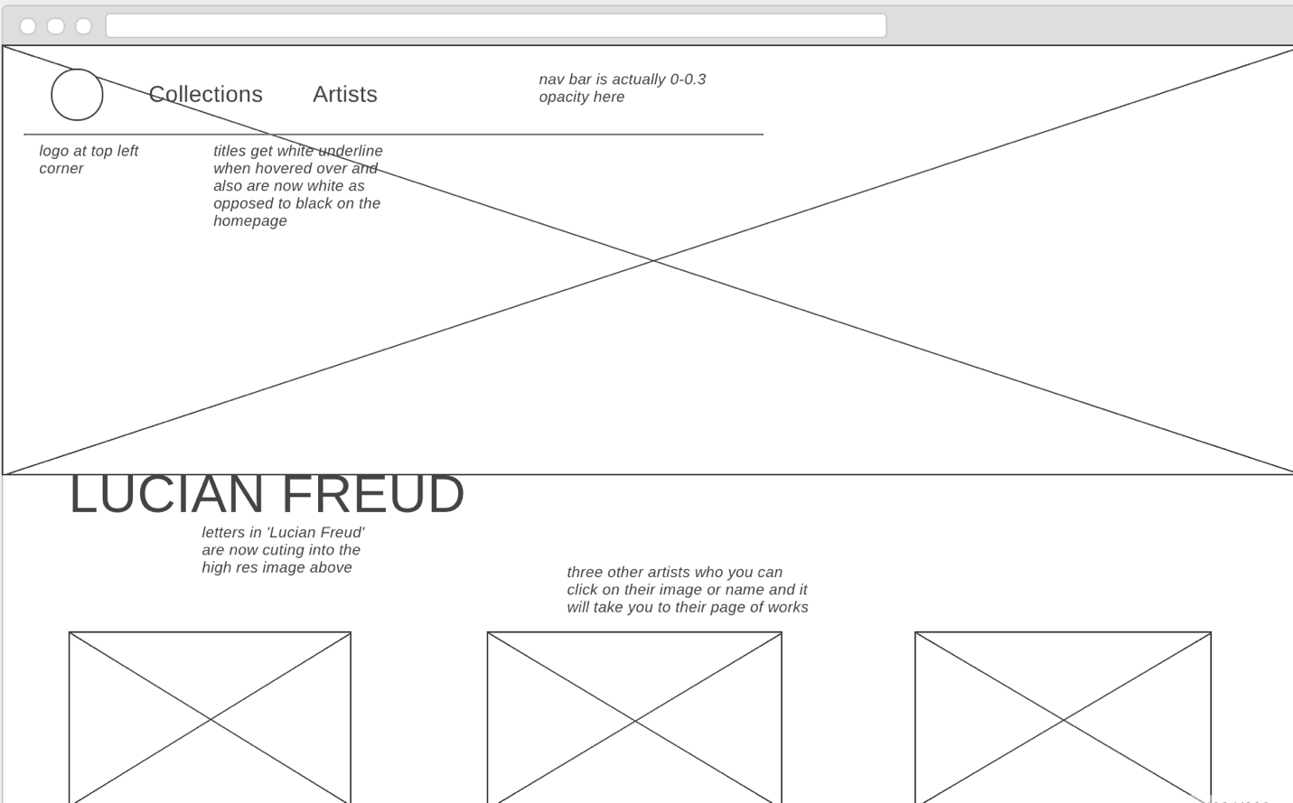

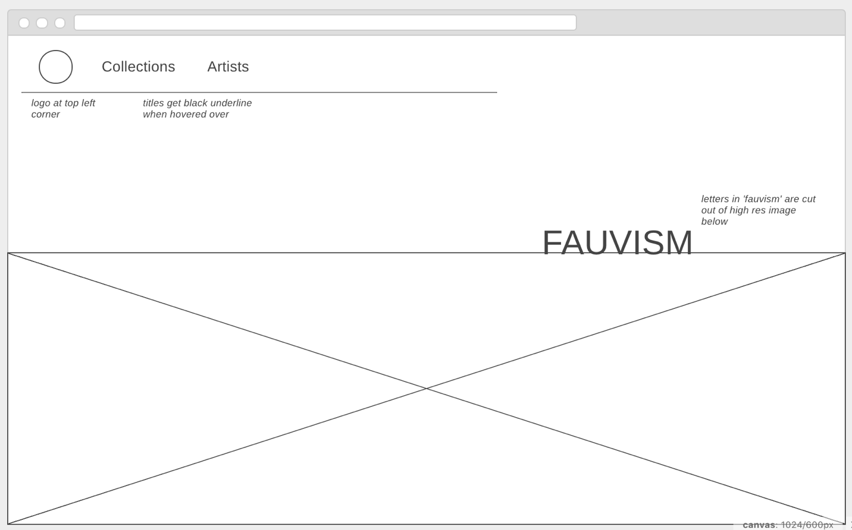

**Description here**

These are two wireframes for my art gallery project. The first wireframe is for my ‘Artists’ page and the second is for the landing page for the website.

|  |  |  |  |
| --- | --- | --- | --- |
| **Unit** | **Ref** | **Evidence** |  |
| **P** | P.10 | Example of Pseudocode used for a method | |

**Paste Screenshot here**

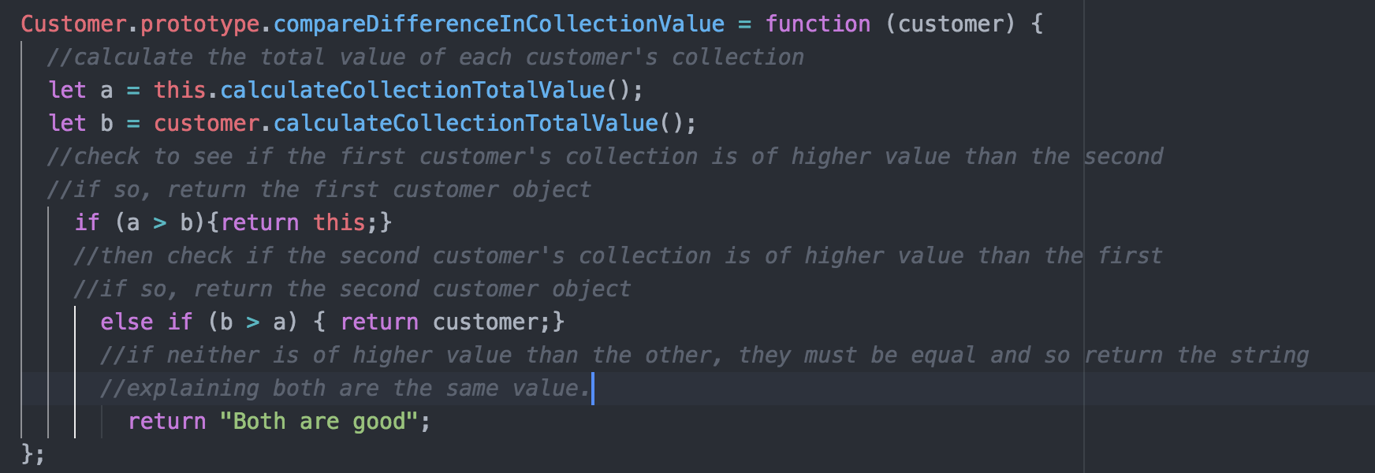

**Description here**

In this method, I am trying to find the collection of the highest value. I pseudo coded each step of the process.

|  |  |  |  |
| --- | --- | --- | --- |
| **Unit** | **Ref** | **Evidence** |  |
| **P** | P.13 | Show user input being processed according to design requirements. Take a screenshot of:  * The user inputting something into your program  * The user input being saved or used in some way | |

**Paste Screenshot here**

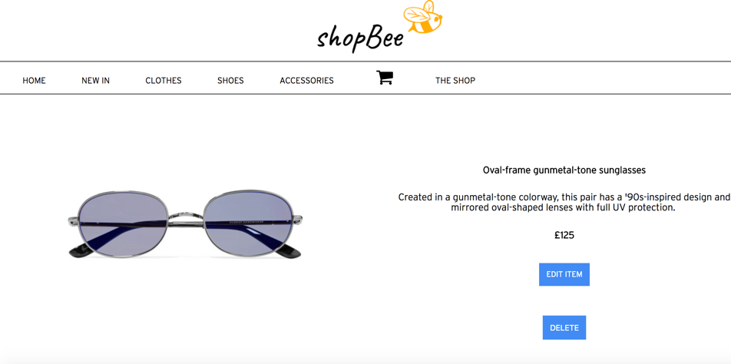

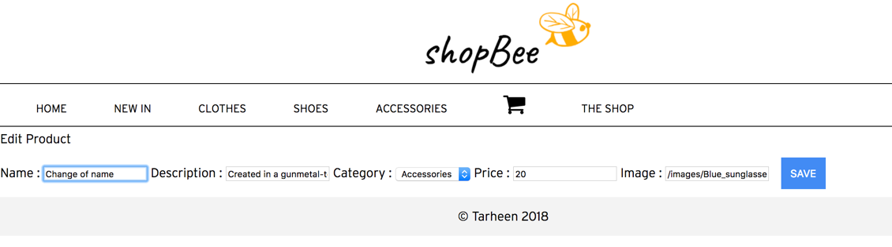

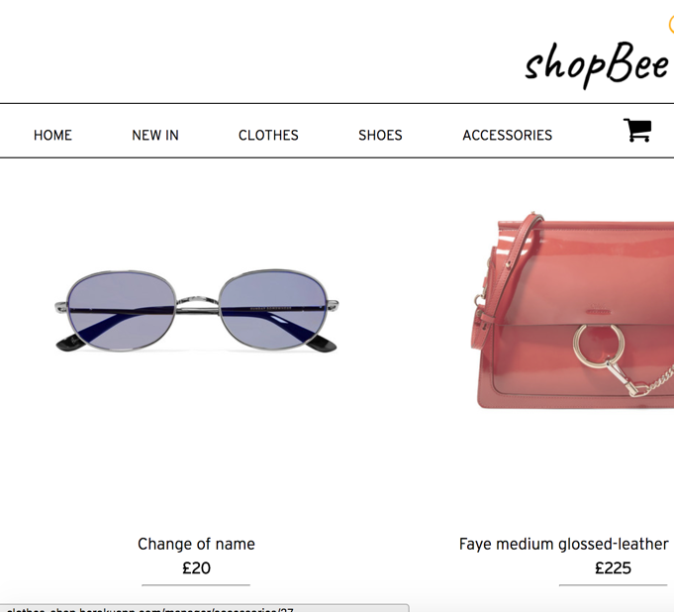

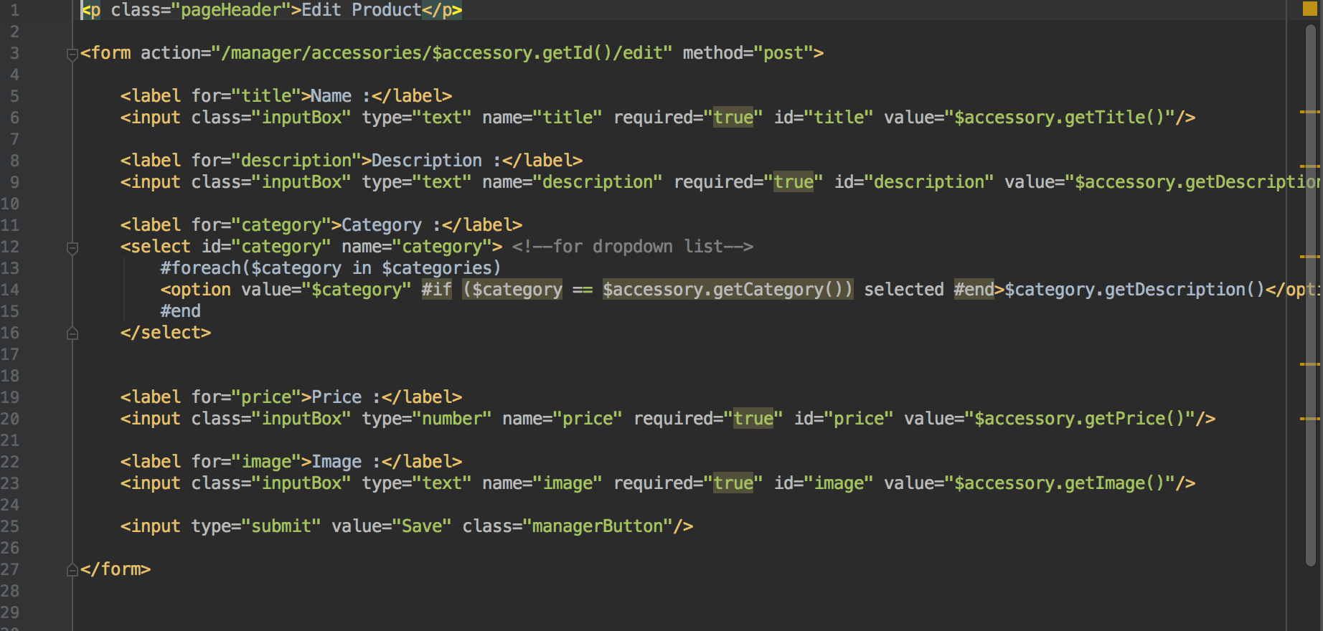

**Description here**

These are screenshots of my clothing store project. You can edit a product and save it to the database. Here I changed the name and price as you can see. Below is the code for the edit page template, specifically for accessories.

|  |  |  |  |
| --- | --- | --- | --- |
| **Unit** | **Ref** | **Evidence** |  |
| **P** | P.14 | Show an interaction with data persistence. Take a screenshot of:  * Data being inputted into your program  * Confirmation of the data being saved | |

**Paste Screenshot here**

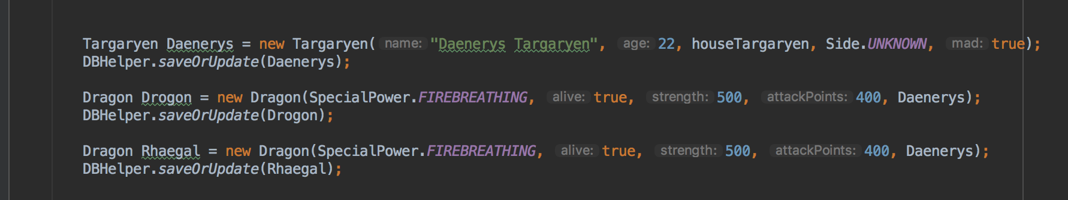

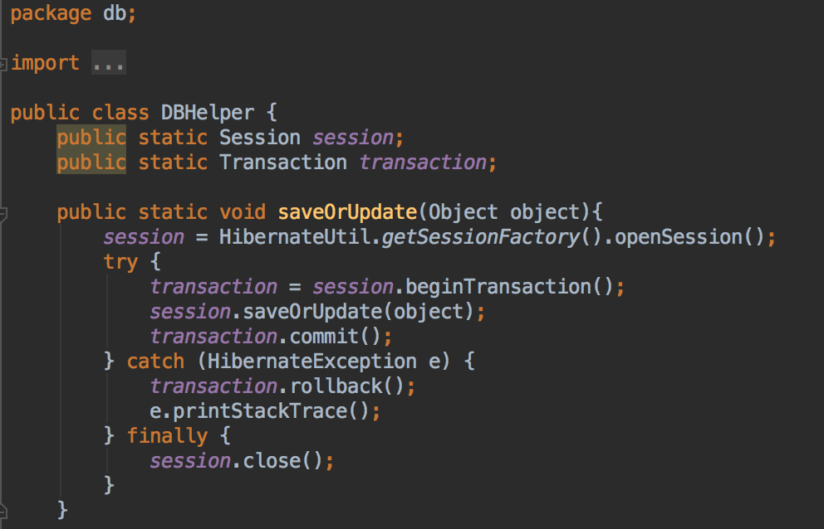

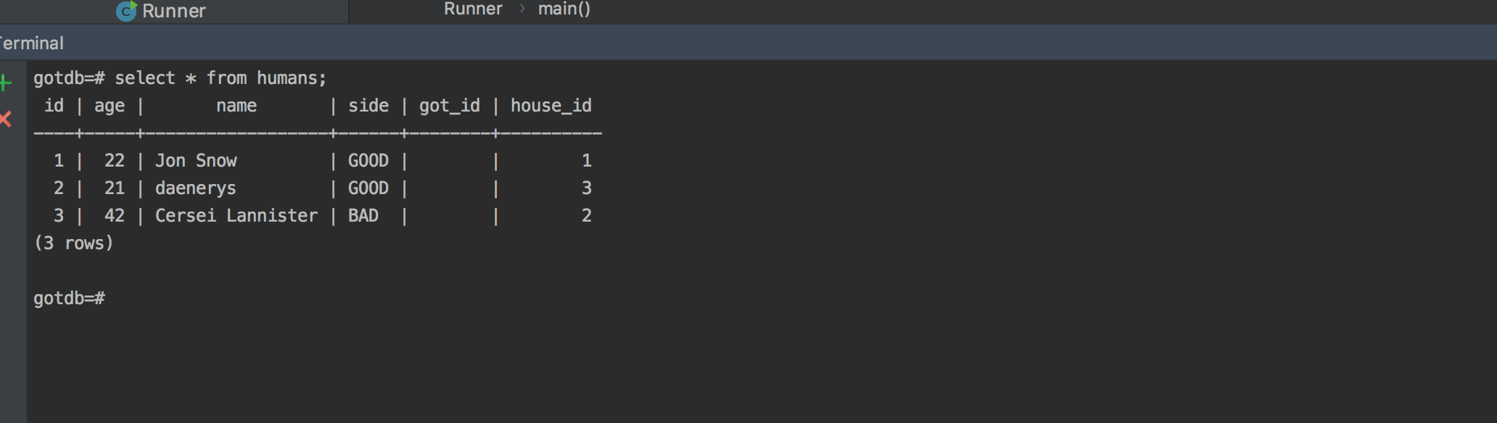

**Description here**

This is an example of a function which saves data to a database and the result of that function successfully saving that data, as seen in terminal.

|  |  |  |  |
| --- | --- | --- | --- |
| **Unit** | **Ref** | **Evidence** |  |
| **P** | P.15 | Show the correct output of results and feedback to user. Take a screenshot of:  * The user requesting information or an action to be performed  * The user request being processed correctly and demonstrated in the program | |

**Paste Screenshot here**

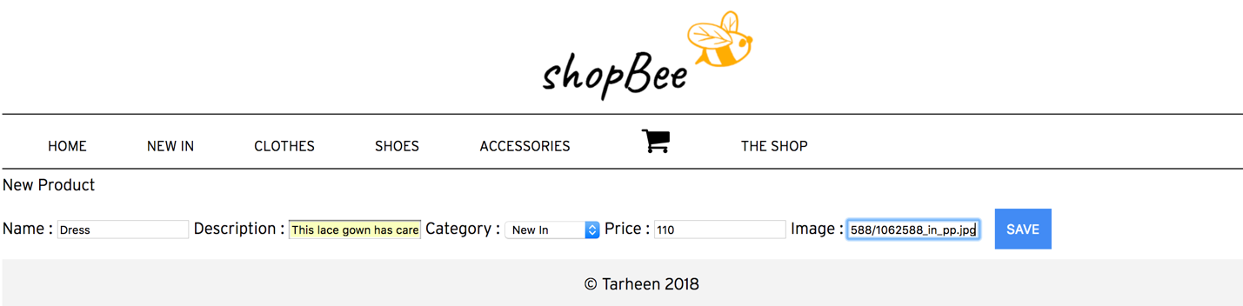

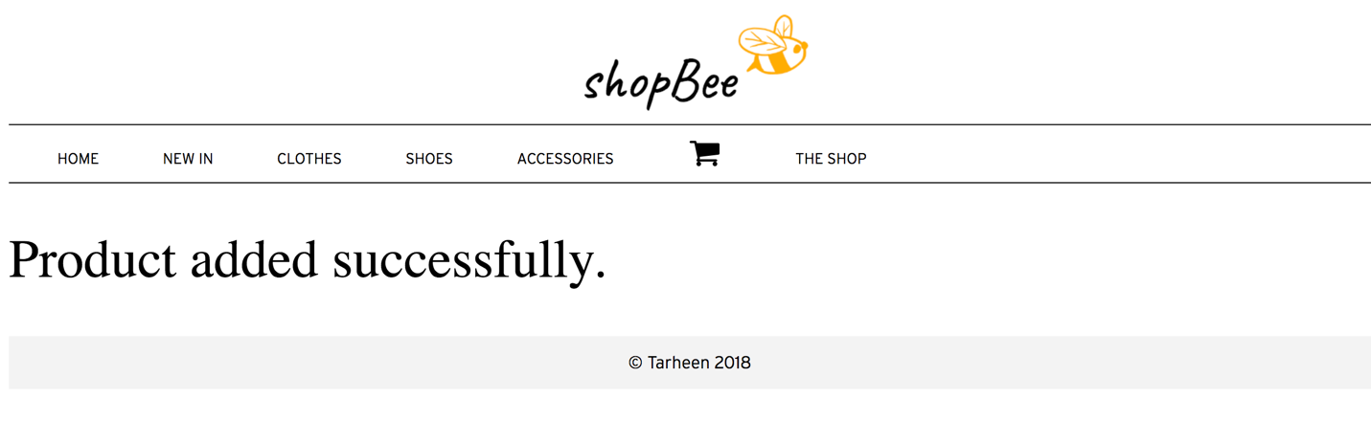

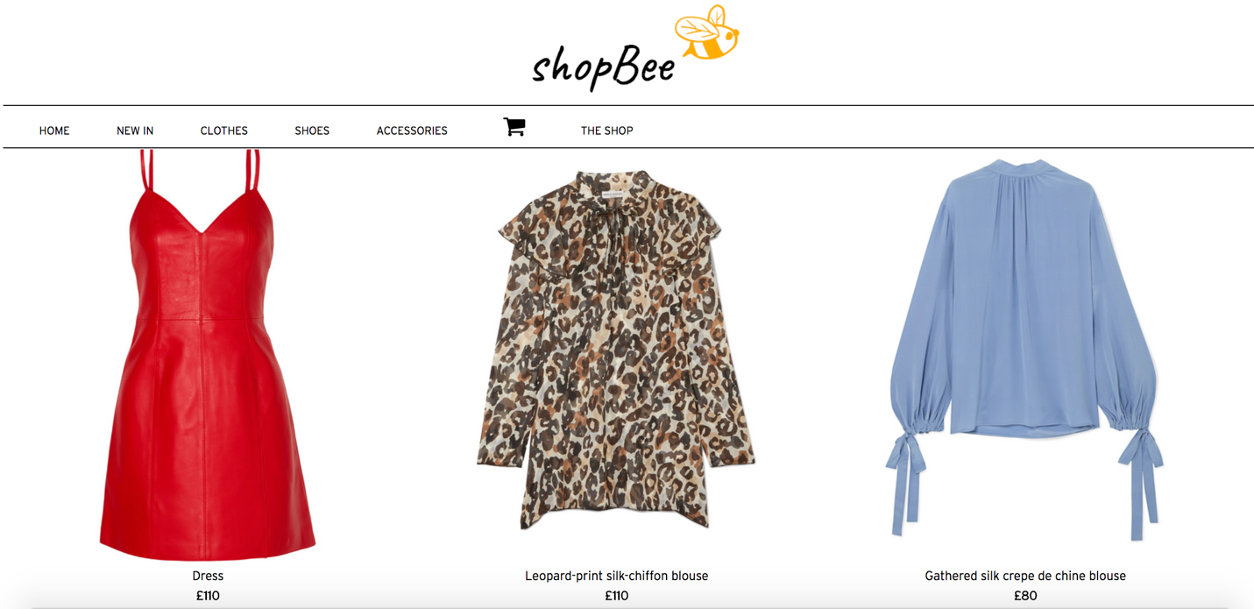

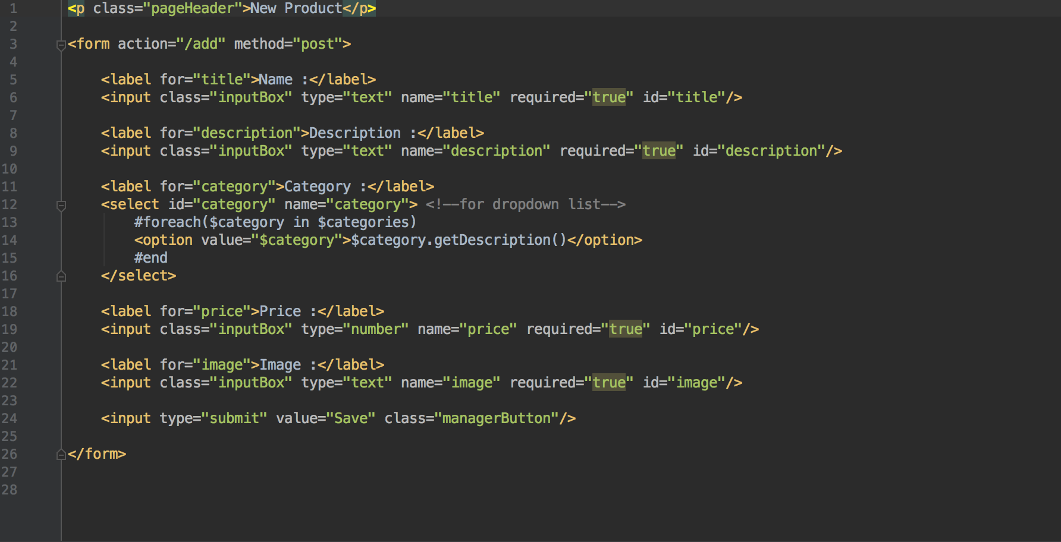

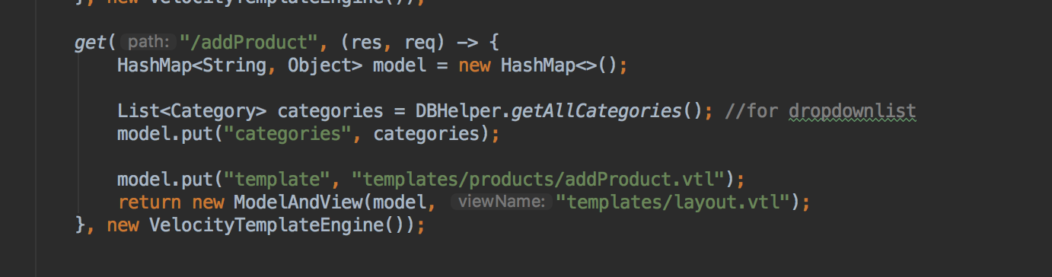

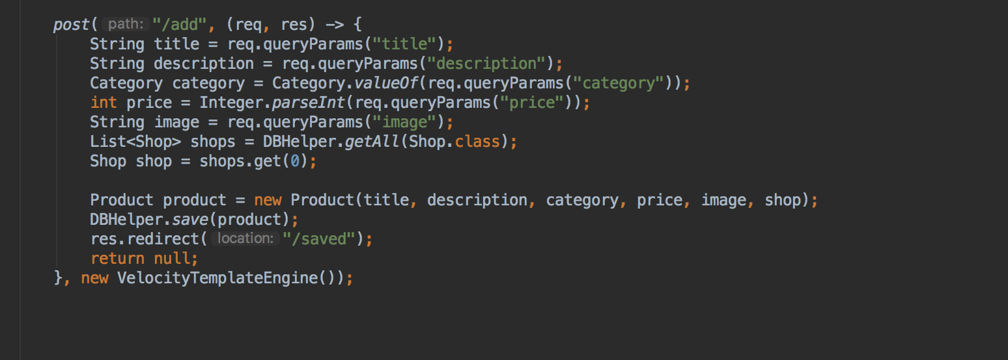

**Description here**

The first few screenshots are of a user adding a new product to the clothing store. The last screenshots are of the ‘add product template’ and the get and post routes used to save the object to the database.

|  |  |  |  |
| --- | --- | --- | --- |
| **Unit** | **Ref** | **Evidence** |  |
| **P** | P.18 | Demonstrate testing in your program. Take screenshots of:  * Example of test code  * The test code failing to pass  * Example of the test code once errors have been corrected  * The test code passing | |

**Paste Screenshot here**

**Test 1**

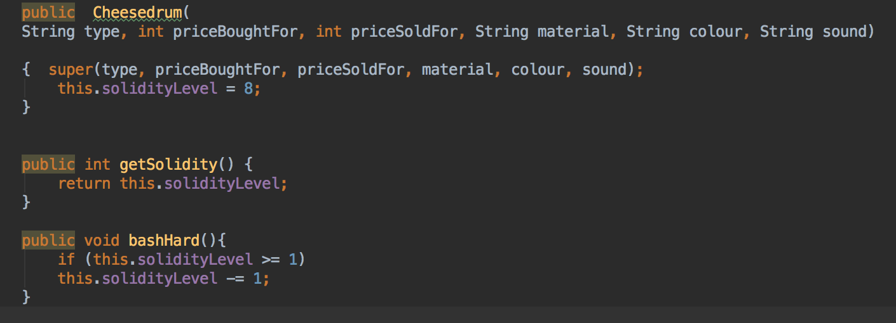

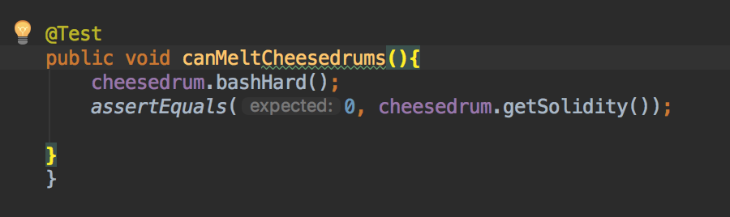

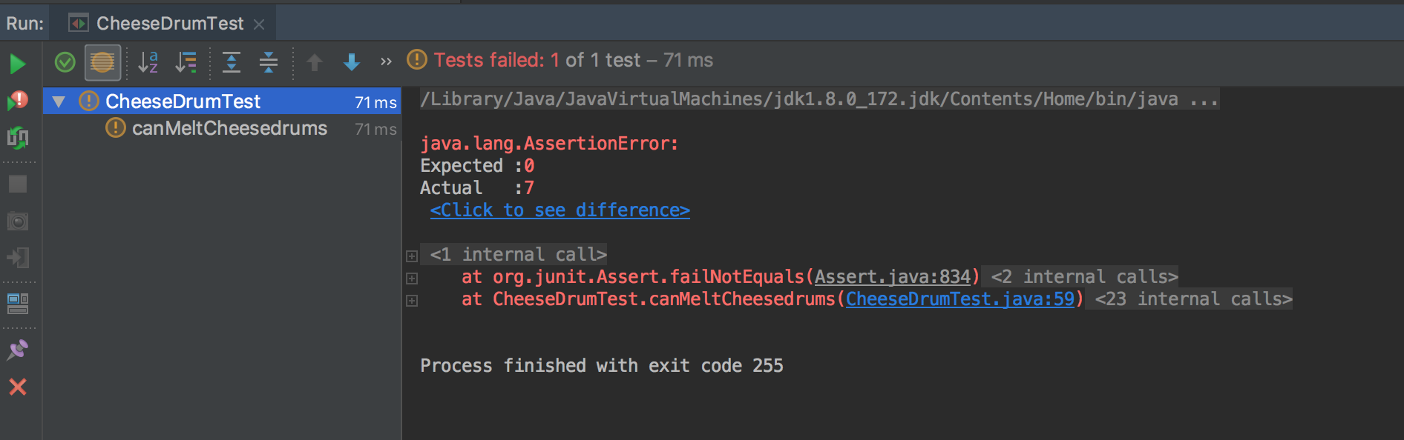

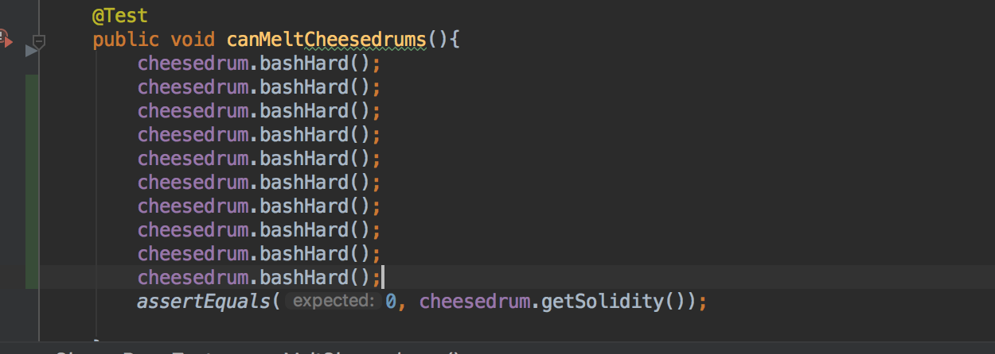

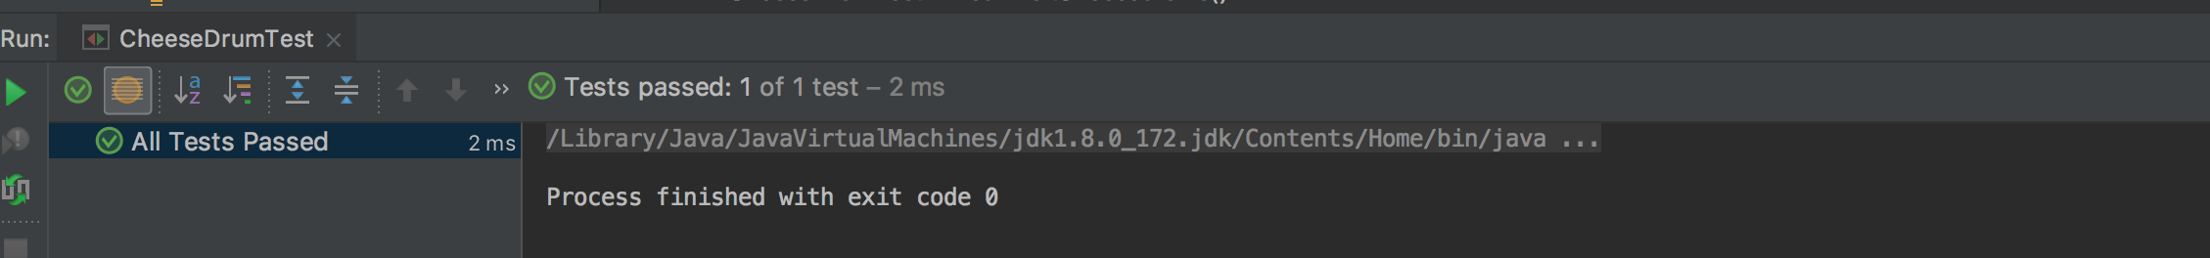

**Description here**

In these screenshots, you can see the Cheese drum class and a test to test the solidity of the cheese drums after they have had the ‘bash hard’ method applied to them. In the first test, it didn’t work as the solidity as at 7 after one application of the ‘bash hard’ method, but the expected outcome was 0. Therefore, in the second test you needed to ‘bash hard’ 8 times for the drums to melt or get to 0.

**Test 2**

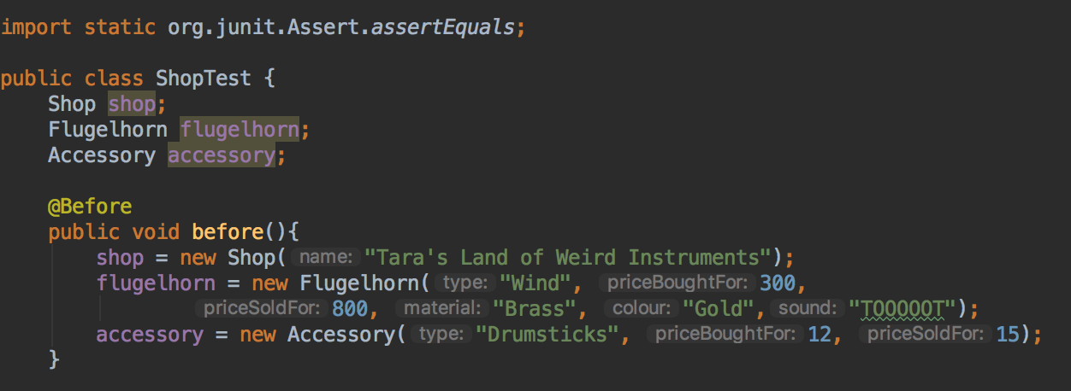

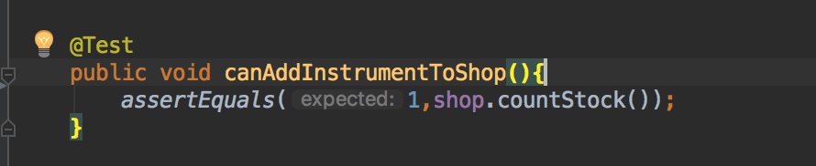

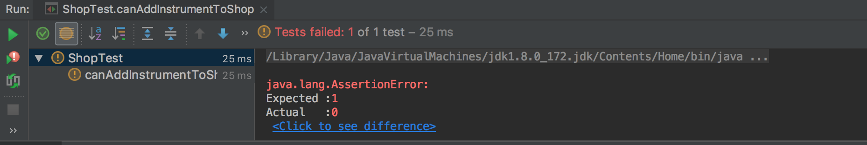

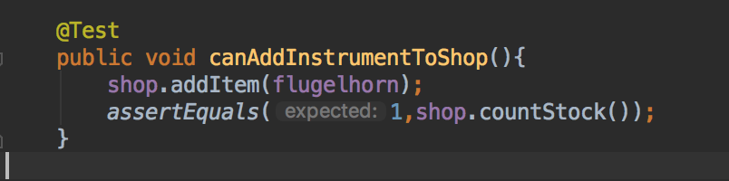

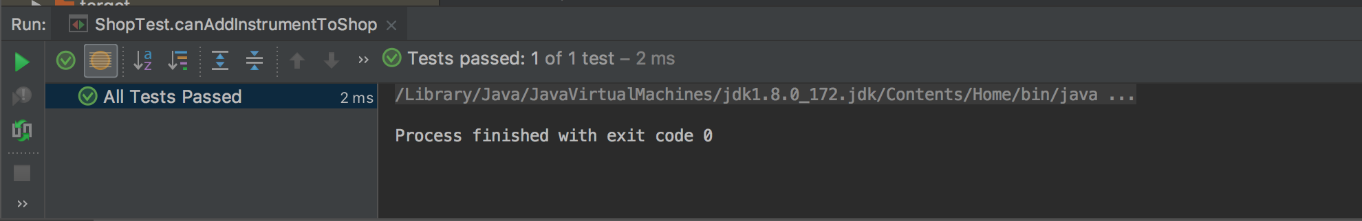

**Description here**

In these screenshots, you can see the shop class which starts out with no instruments added to it. In the test, I assert there is already one instrument in the shop which there isn’t and is why the test fails. In the second test I have put an instrument into the shop and so the test passes.

**Test 3**

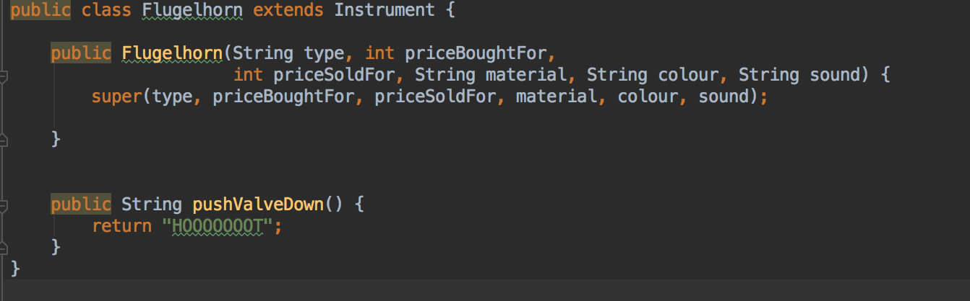

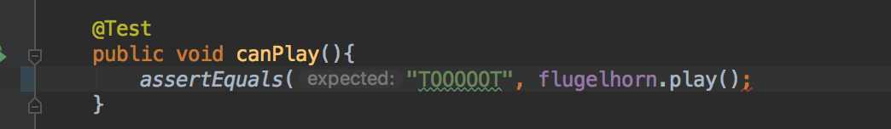

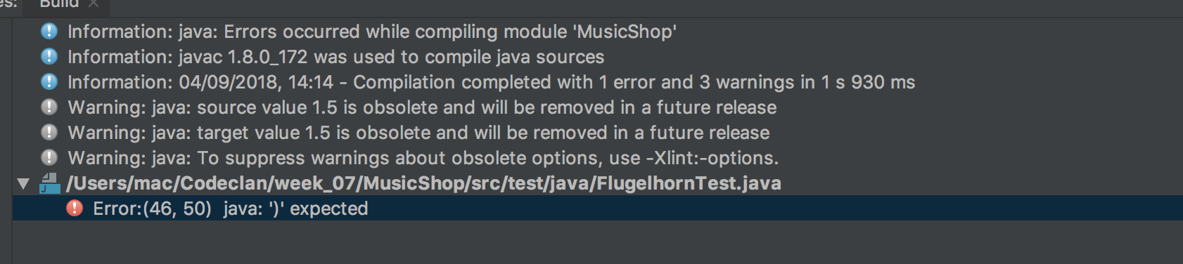

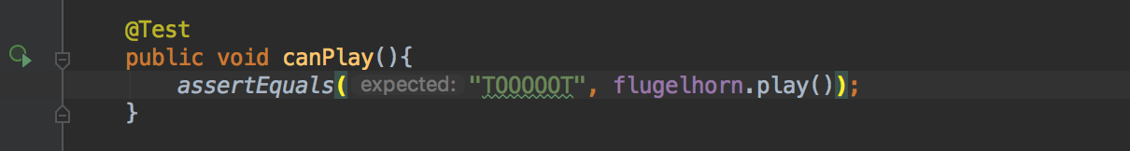

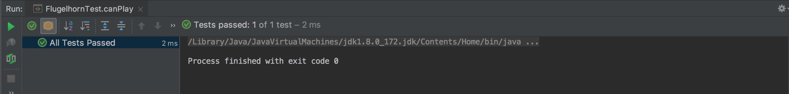

**Description here**

In this test, I am testing whether the flugelhorn can play, however in my test there is a missing end bracket, which is why the test fails. I add one more round bracket on the end of the assertEquals line and the test passes.

**Test 4**

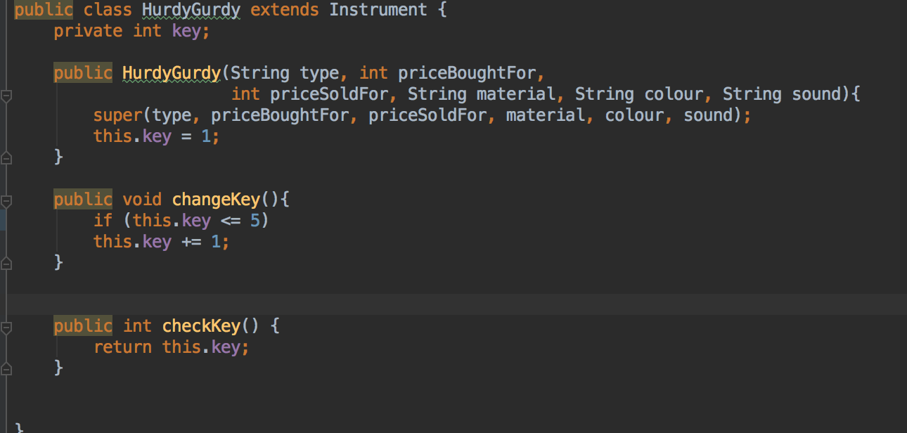

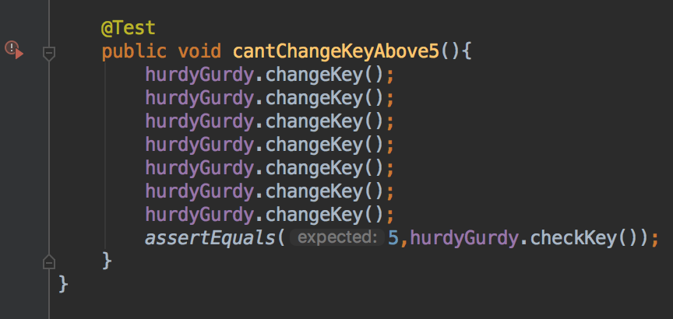

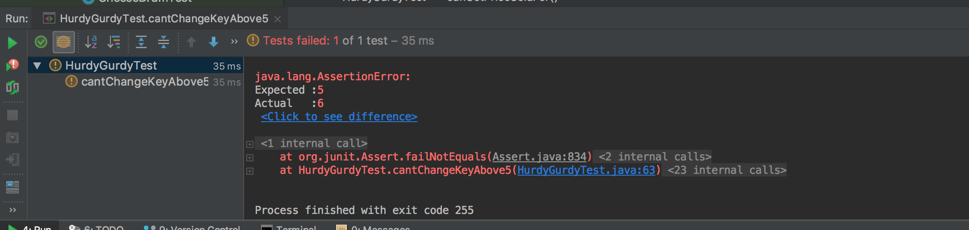

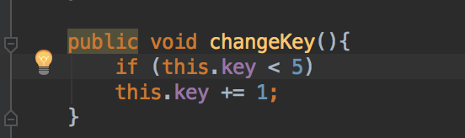

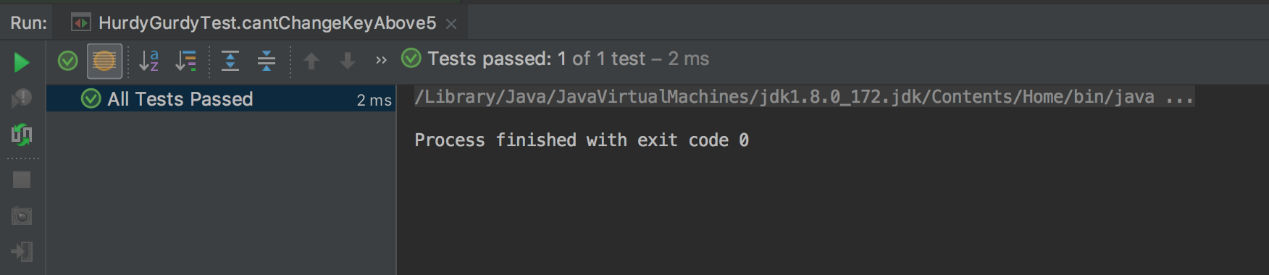

**Description here**

In this test, my test fails as I have attempted to change the key 7 times and I want to cap the key changes to 5 at most. However, in changeKey() method I have the key limit to being less than or equals to 5, whereas it needs to be just less than 5. Therefore, I changed the if condition to be just less than 5.

**Test 5**

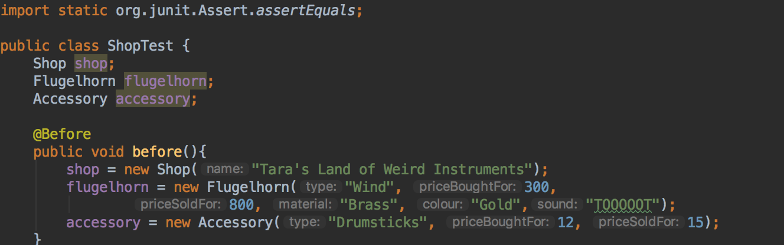

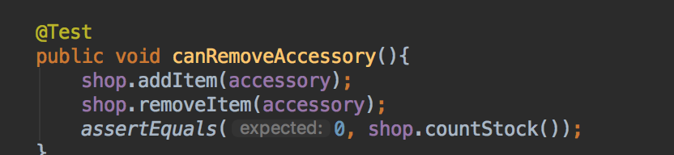

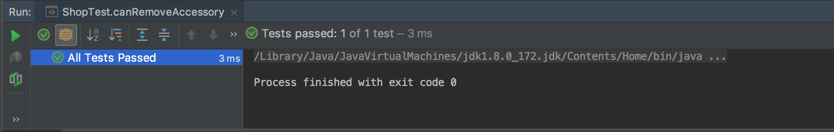

**Description here**

In this test, I am testing the ability to remove an item from a shop. First, I add an item, then remove it and count the shop stock. As the code is correct, the test passes.

**Week 7**

|  |  |  |  |
| --- | --- | --- | --- |
| **Unit** | **Ref** | **Evidence** |  |
| **I&T** | I.T.7 | The use of Polymorphism in a program and what it is doing. | |

**Paste Screenshot here**

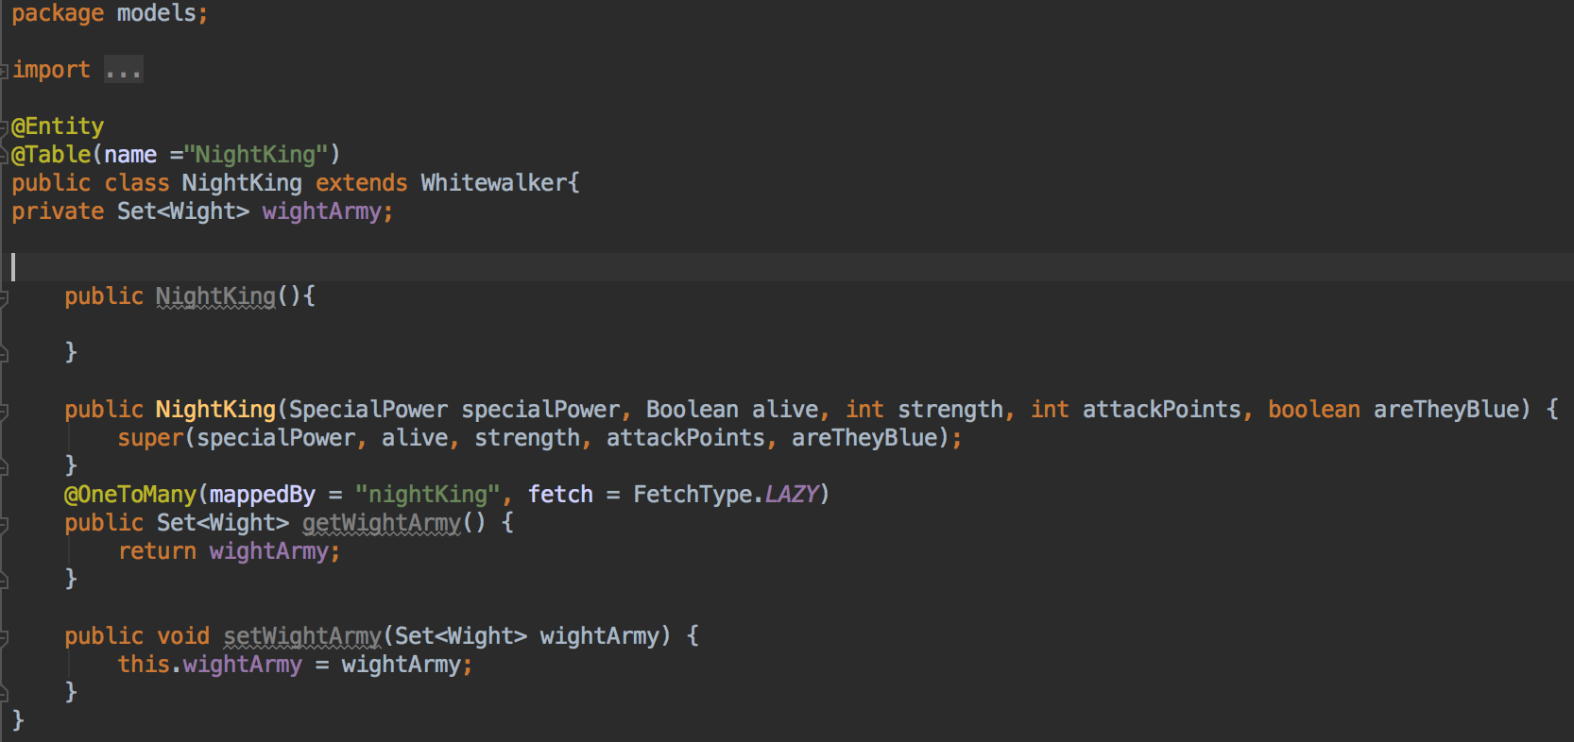

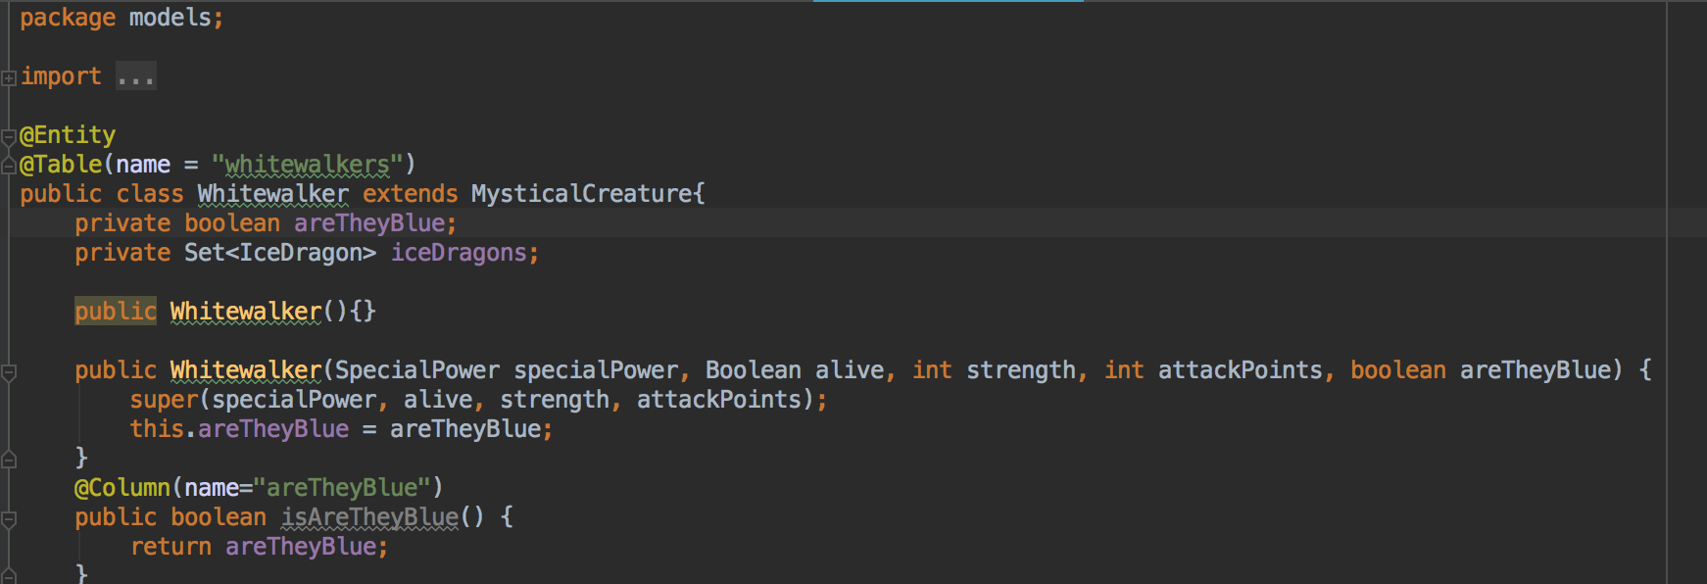

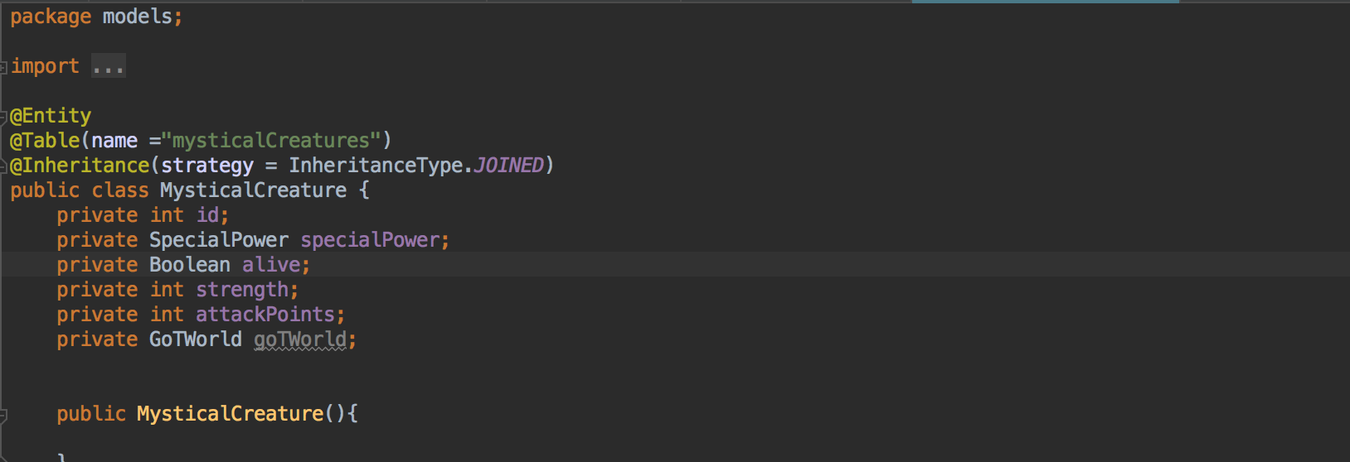

**Description here**

These images demonstrate polymorphism in a program. They show that the Night King object is polymorphic as he extends from the Whitewalker class and the Mystical Creature class. He is therefore taking many forms as he takes properties from both class with multiple inheritance.

|  |  |  |  |
| --- | --- | --- | --- |
| **Unit** | **Ref** | **Evidence** |  |
| **A&D** | A.D.5 | An Inheritance Diagram | |

**Paste Screenshot here**

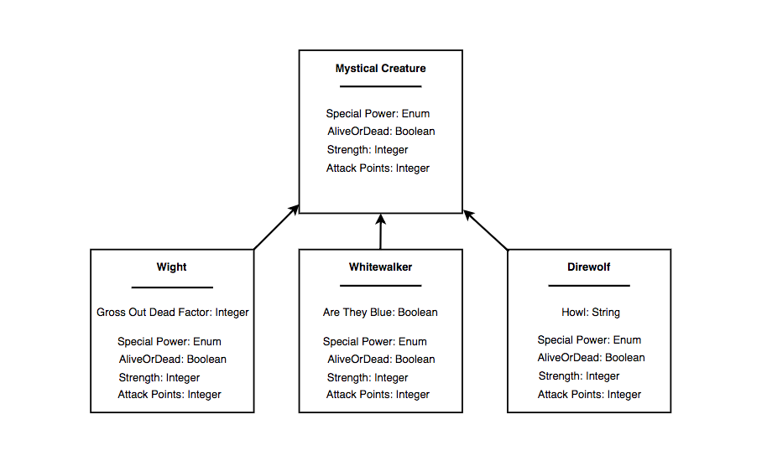

**Description here**

This is an inheritance diagram based on the creatures from Game of Thrones. All Wights, Whitewalkers and Direwolves inherit from the class of Mystical Creature, which has certain features. They each then have separate properties which differentiate them from each other, such as the Gross Out Dead Factor, whether they are blue or not and the fact that direwolves can howl.

|  |  |  |  |
| --- | --- | --- | --- |
| **Unit** | **Ref** | **Evidence** |  |
| **I&T** | I.T.1 | The use of Encapsulation in a program and what it is doing. | |

**Paste Screenshot here**

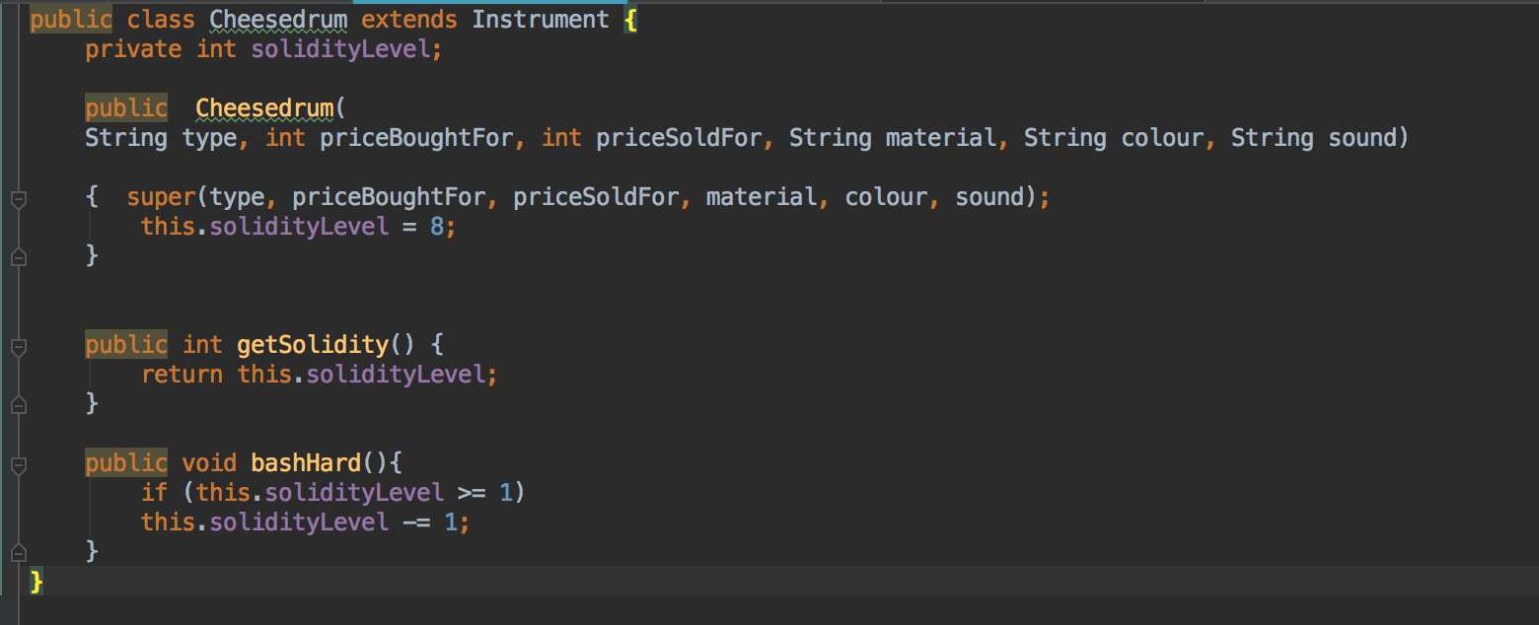

**Description here**

In this image, we can see the property of ‘Solidity’ of the Cheese Drum class being encapsulated. This means that this property is privatized, and you cannot access this property from outside the Cheese Drum class. To do this you would need to use the getter and setter methods.

|  |  |  |  |
| --- | --- | --- | --- |
| **Unit** | **Ref** | **Evidence** |  |
| **I&T** | I.T.2 | Take a screenshot of the use of Inheritance in a program. Take screenshots of:  *A Class  *A Class that inherits from the previous class  *An Object in the inherited class  *A Method that uses the information inherited from another class. | |

**Paste Screenshot here**

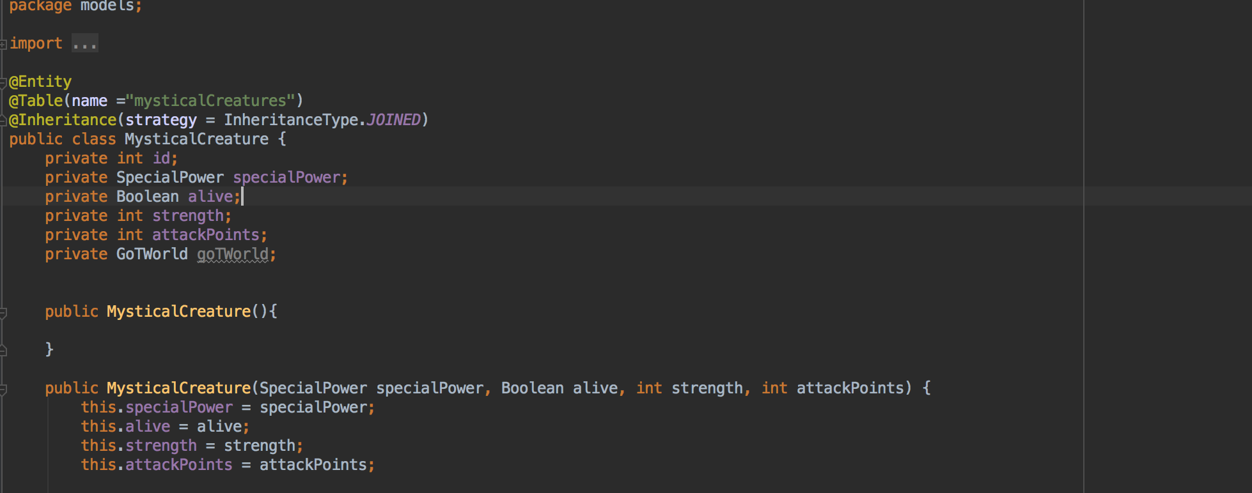

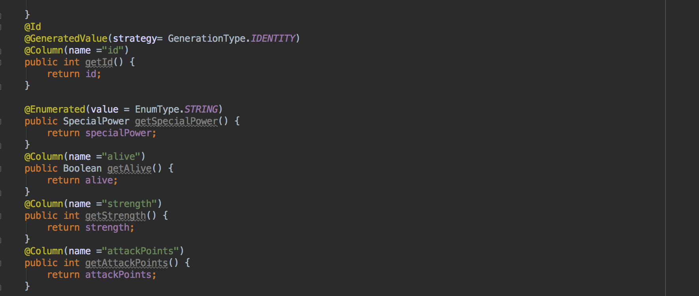

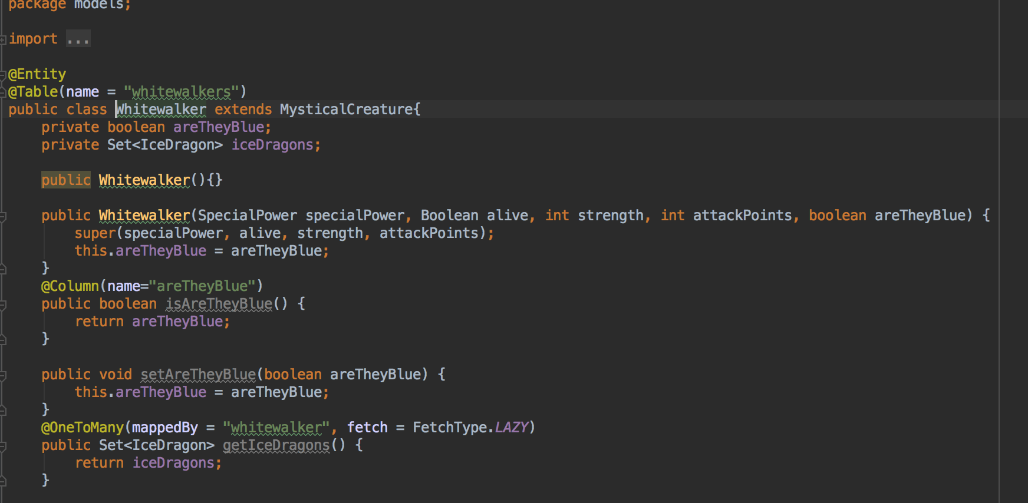

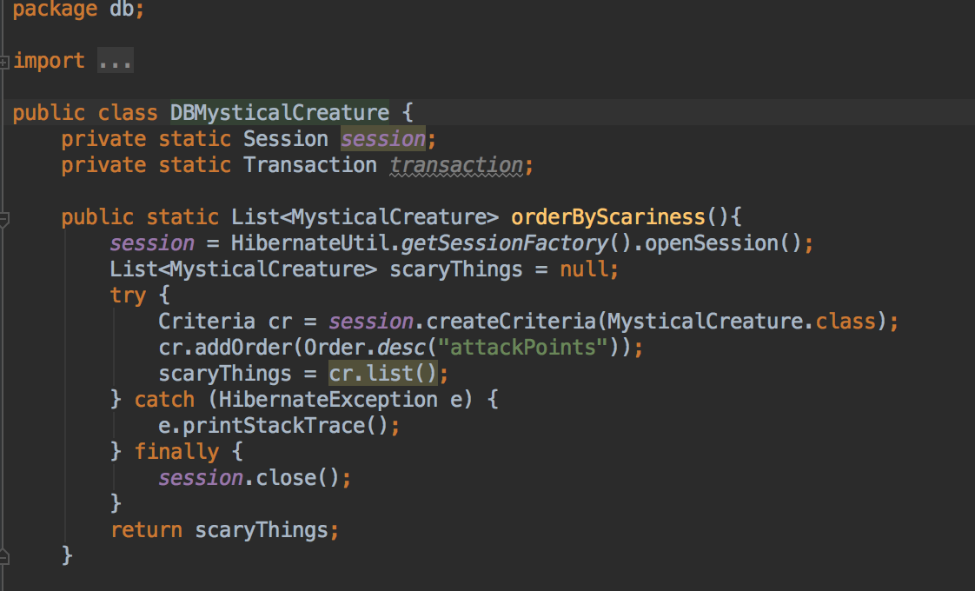



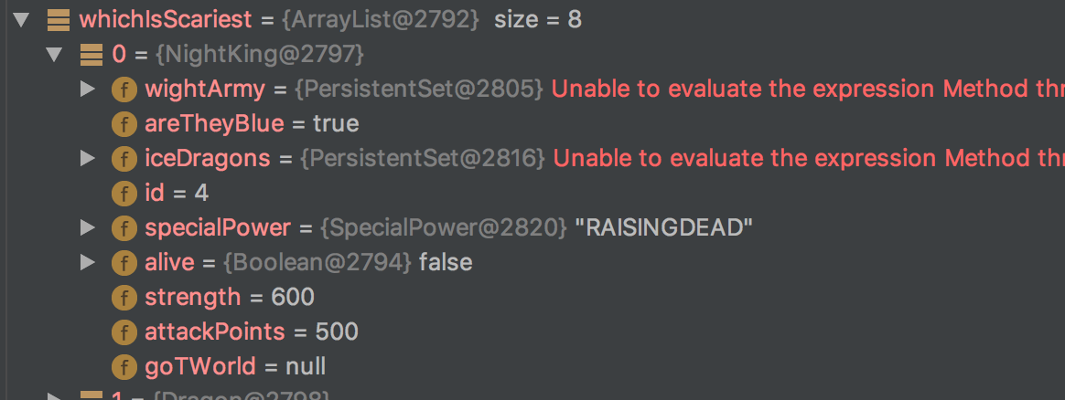

**Description here**

The first screenshot is of the Mystical Creature class and the second screenshot is of the Whitewalker class, which inherits from the Mystical Creature class. We then have a method which sorts mystical creatures in order of their attack points or ‘scariness level’. The last two shots are of the method being used and the result of the method which returns the ‘Night King’, who extends Whitewalker and therefore Mystical Creature.

**Week 10**

|  |  |  |  |
| --- | --- | --- | --- |
| **Unit** | **Ref** | **Evidence** |  |
| **P** | P.11 | Take a screenshot of one of your projects where you have worked alone and attach the Github link. | |

**Paste Screenshot here**

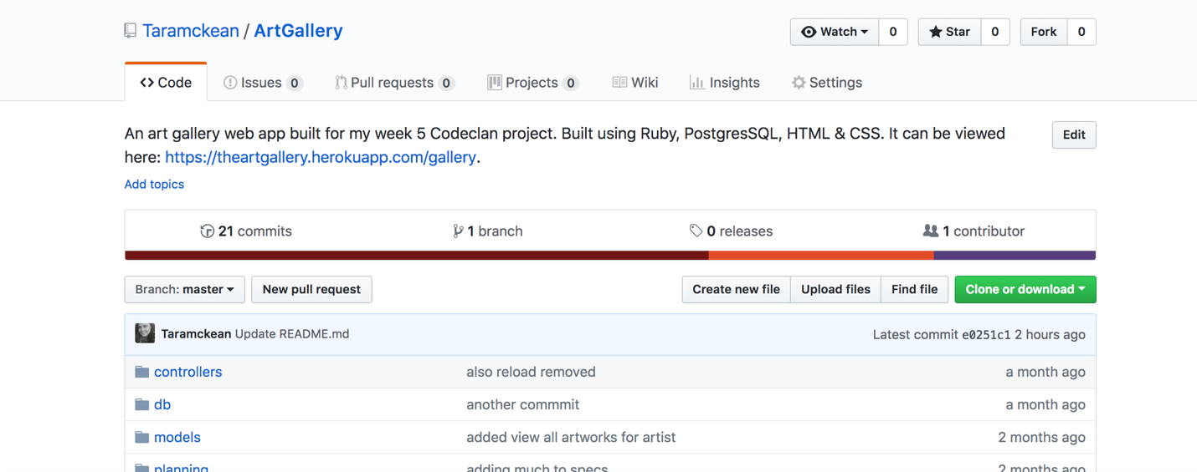



[**My project link: https://github.com/Taramckean/ArtGallery**](https://github.com/Taramckean/ArtGallery)

**Description here**

These are screenshots of my solo Ruby project, where I created an art gallery using Ruby, PostgresSQL, HTML & CSS. Below them is a link to view it on Github.

|  |  |  |  |
| --- | --- | --- | --- |
| **Unit** | **Ref** | **Evidence** |  |
| **P** | P.12 | Take screenshots or photos of your planning and the different stages of development to show changes. | |

**Paste Screenshot here**

Class Diagrams

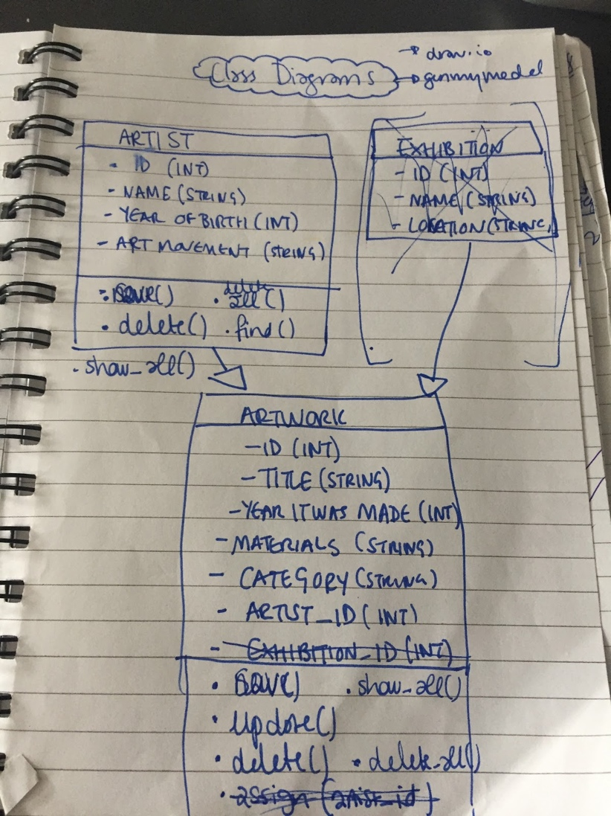

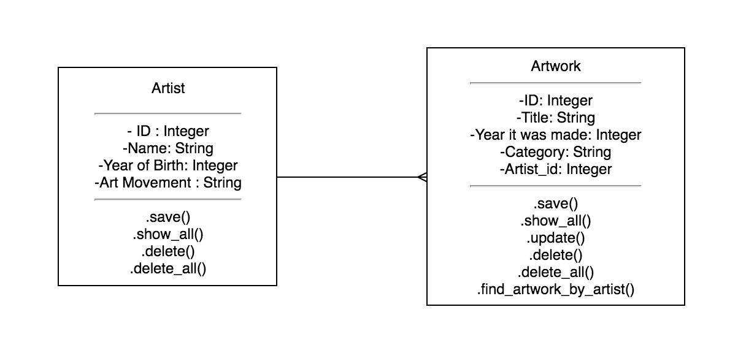

Object Diagrams

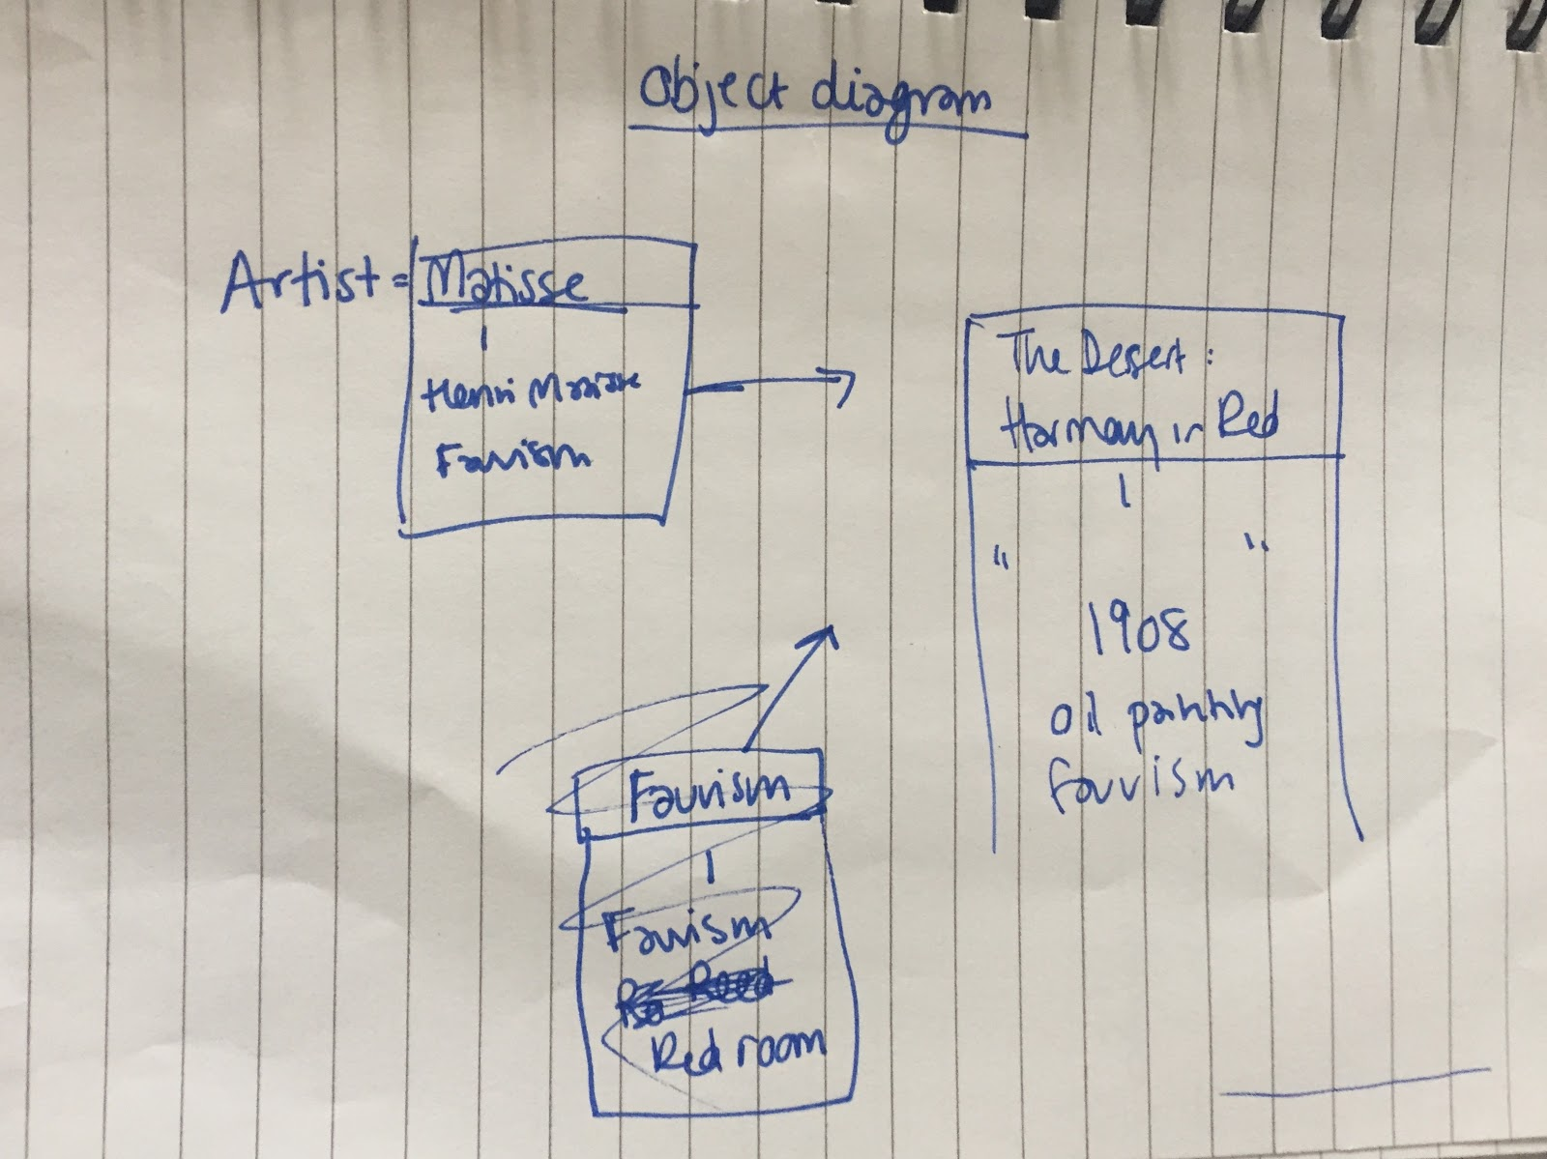



Sitemaps

*Original:*

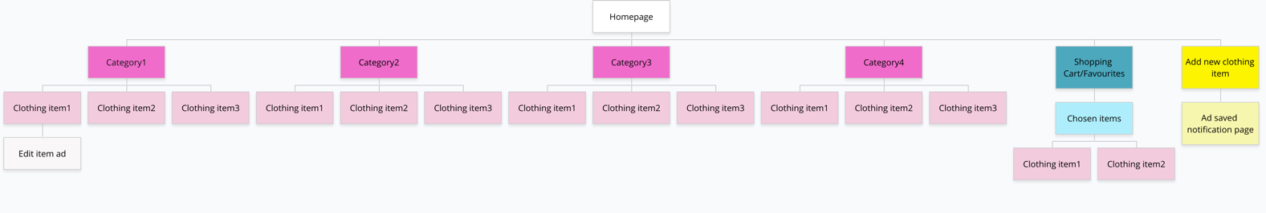

*Split out:*

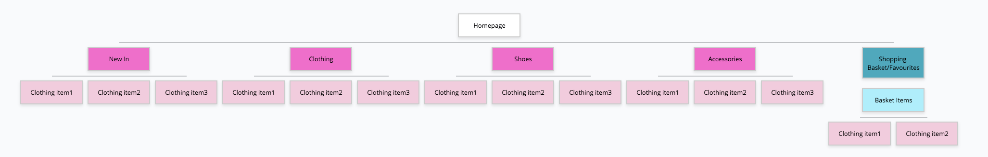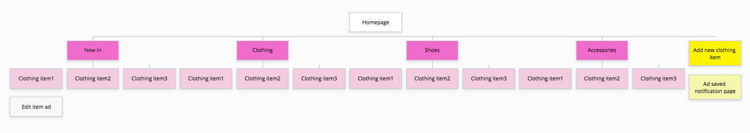

**Description here**

These are screenshots of my planning initially for my art gallery project and then the final plans before I started coding. I changed my class diagram by cutting my classes down from three to two. I changed my object diagrams by clarifying for myself what an object diagram was. Finally, in my clothing shop project, I changed the sitemap from one map to two as we decided to split out the manager and customer’s functionality.

|  |  |  |  |
| --- | --- | --- | --- |
| **Unit** | **Ref** | **Evidence** |  |
| **P** | P.9 | Select two algorithms you have written (NOT the group project). Take a screenshot of each and write a short statement on why you have chosen to use those algorithms. | |

**Paste Screenshot here**

Algorithm 1:

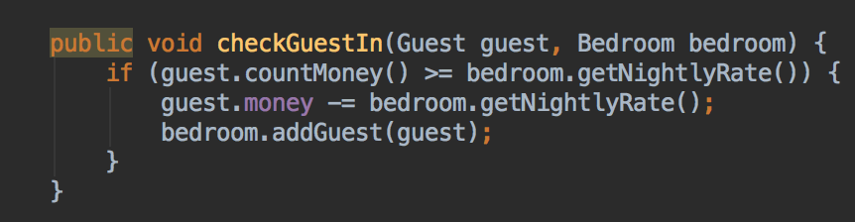

This is an algorithm in java to check whether a guest has enough money to rent a room, and if they do, they are added to the room and the nightly rate is taken away from the guest’s money.

Algorithm 2:

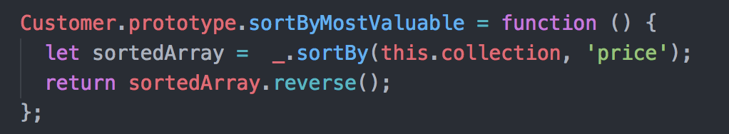

This algorithm sorts records in a collection by their price using Lodash. Since Lodash default sorts values in ascending order, I then used Javascript’s ‘reverse’ method to get the list in descending order and thus can get the most valuable record by taking the first element in the resulting array.

**Week 12**

|  |  |  |  |
| --- | --- | --- | --- |
| **Unit** | **Ref** | **Evidence** |  |
| **P** | P.16 | Show an API being used within your program. Take a screenshot of:  * The code that uses or implements the API  * The API being used by the program whilst running | |

**Paste Screenshot here**

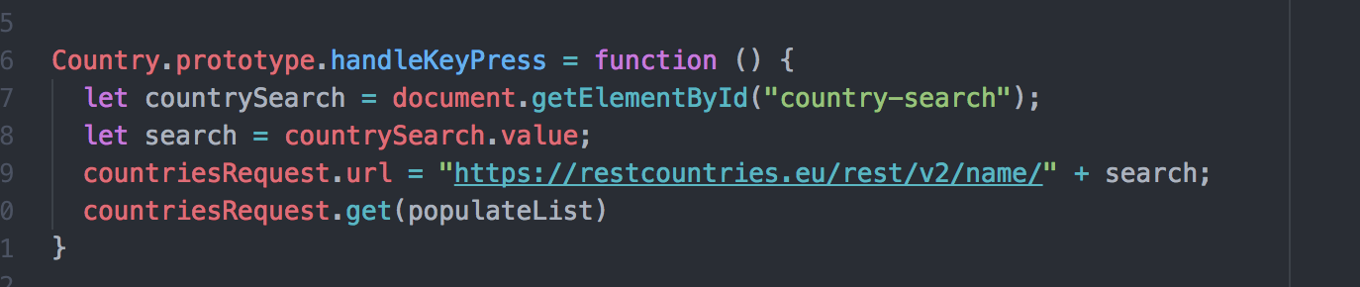

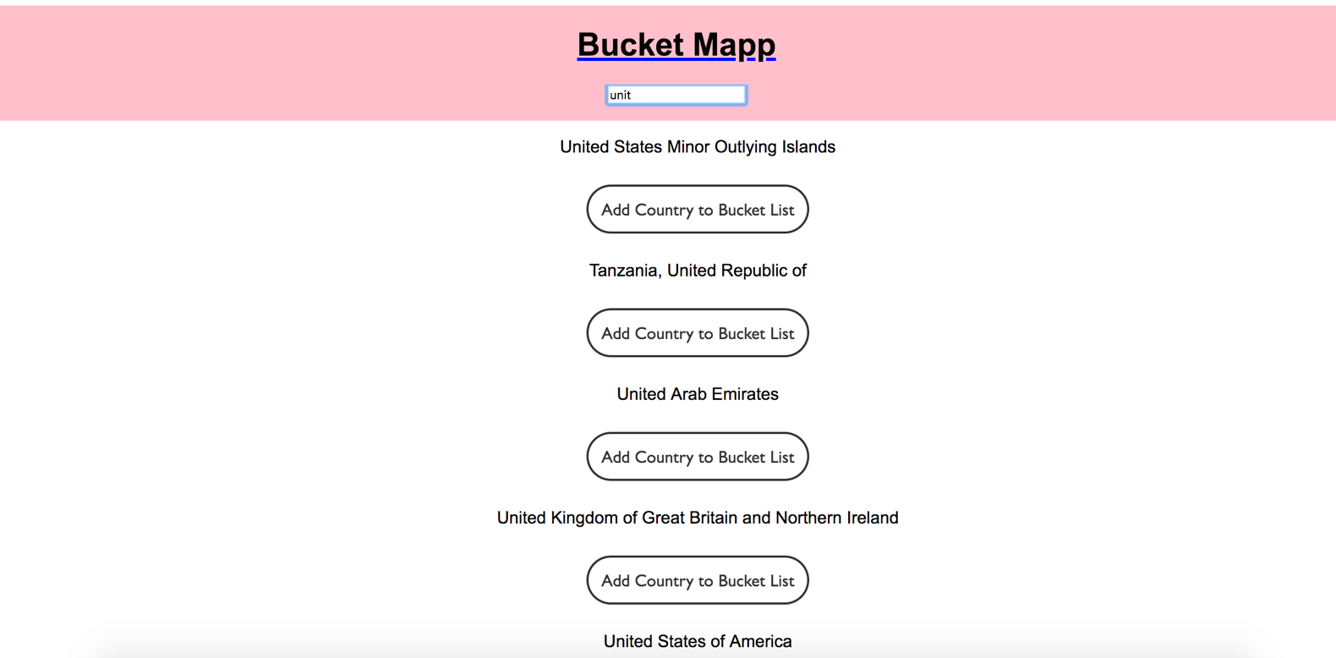

**Description here**

In the first screenshot, you can see the code used to dynamically populate a list with countries. Every time you press a key, the program searches through the API for a country with a matching combination of letters and populates the list below. You can see the result of this in the second screenshot.

**Week 15**

|  |  |  |  |
| --- | --- | --- | --- |
| **Unit** | **Ref** | **Evidence** |  |
| **P** | P.1 | Take a screenshot of the contributor’s page on GitHub from your group project to show the team you worked with. | |

**Paste Screenshot here**

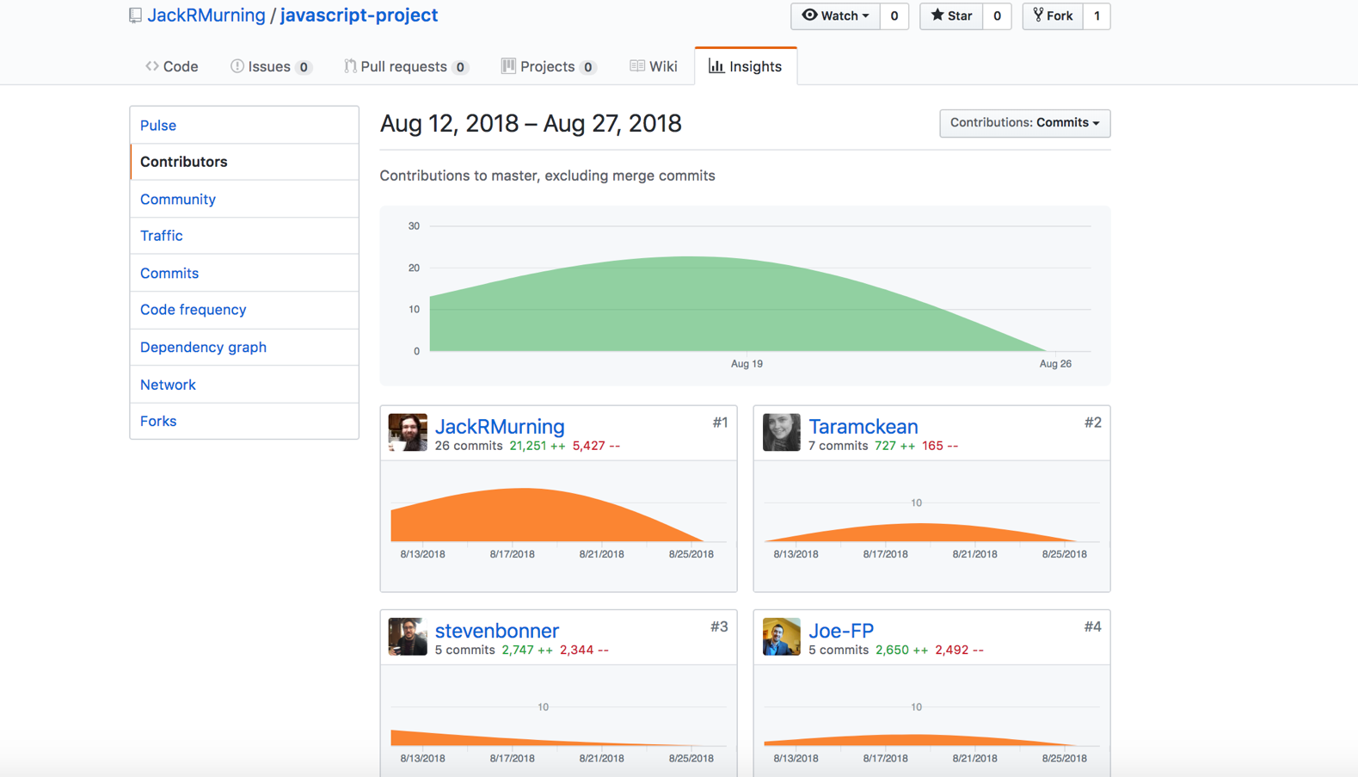

**Description here**

This is a screenshot of our group project’s contributor page.

|  |  |  |  |
| --- | --- | --- | --- |
| **Unit** | **Ref** | **Evidence** |  |
| **P** | P.2 | Take a screenshot of the project brief from your group project. | |

**Paste Screenshot here**

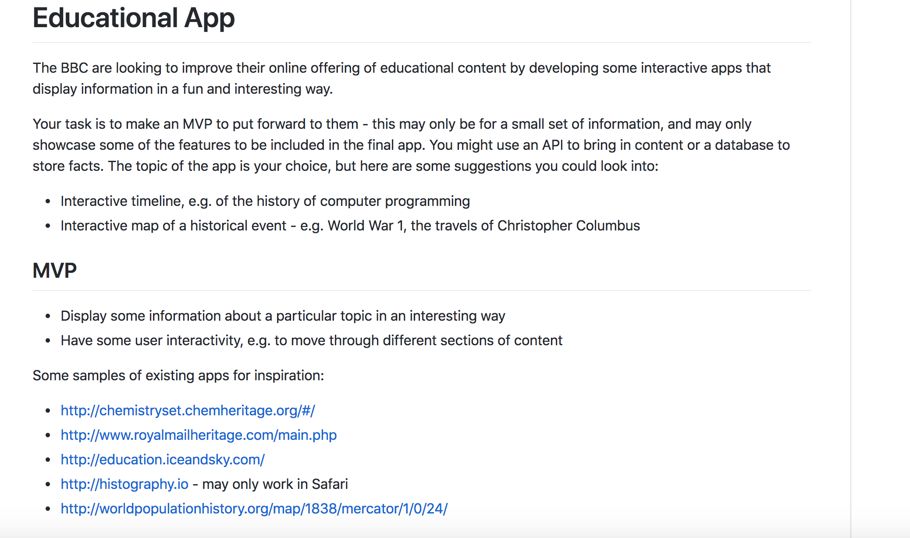

**Description here**

This is the brief for our group project. We did an educational app designed to teach kids how to code in an interactive and fun way.

|  |  |  |  |
| --- | --- | --- | --- |
| **Unit** | **Ref** | **Evidence** |  |
| **P** | P.3 | Provide a screenshot of the planning you completed during your group project, e.g. Trello MOSCOW board. | |

**Paste Screenshot here**

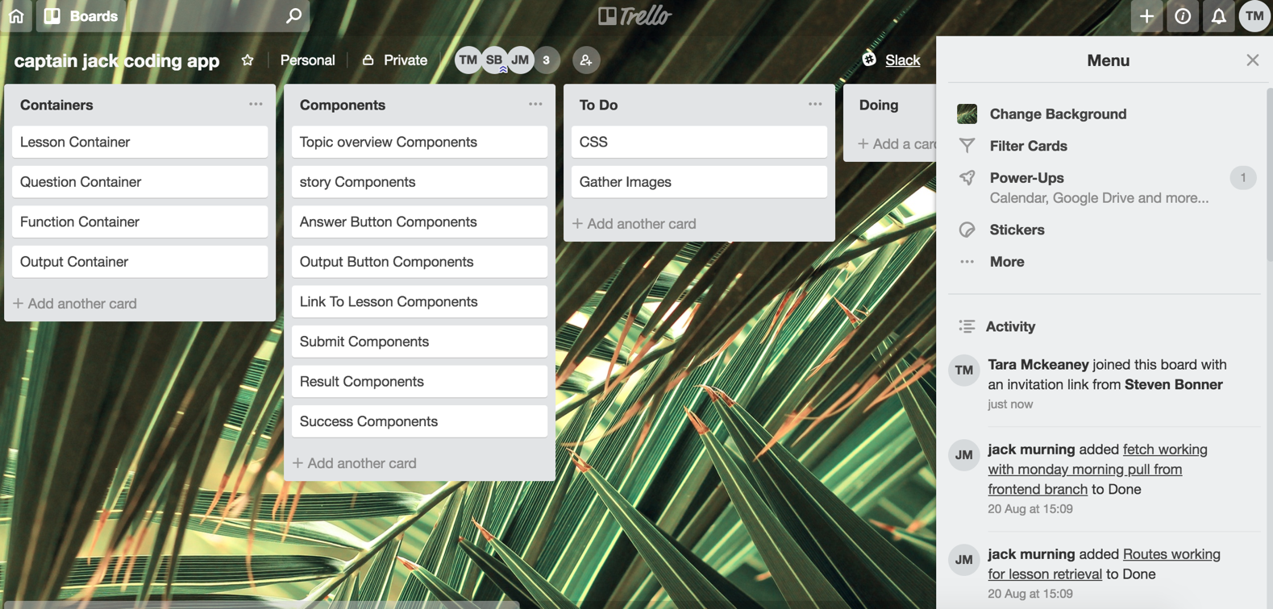

**Description here**

This is the Trello board we used throughout our group project.

|  |  |  |  |
| --- | --- | --- | --- |
| **Unit** | **Ref** | **Evidence** |  |
| **P** | P.4 | Write an acceptance criteria and test plan. | |

**Paste Screenshot here**

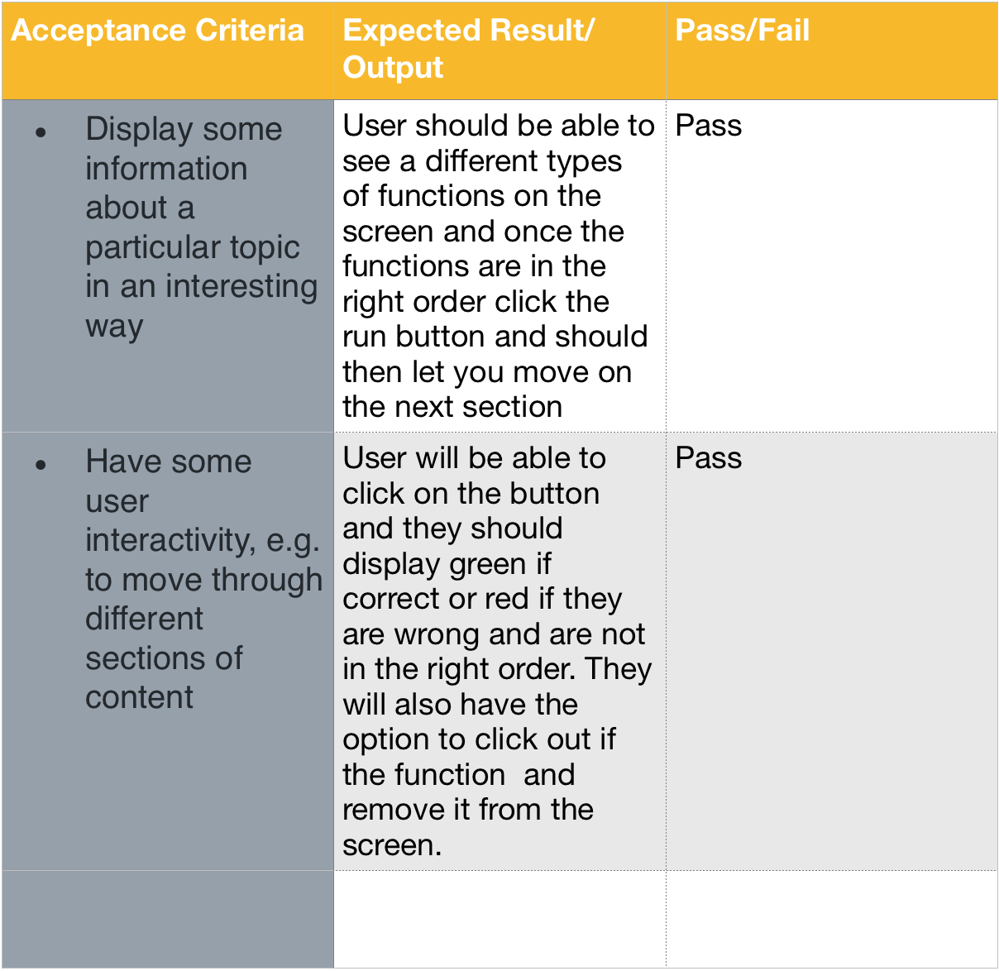

**Description here**

This is an acceptance criteria plan which shows that the functionality required for our MVP passes the tests.

|  |  |  |  |
| --- | --- | --- | --- |
| **Unit** | **Ref** | **Evidence** |  |
| **P** | P.7 | Produce two system interaction diagrams (sequence and/or collaboration diagrams). | |

**Paste Screenshot here**

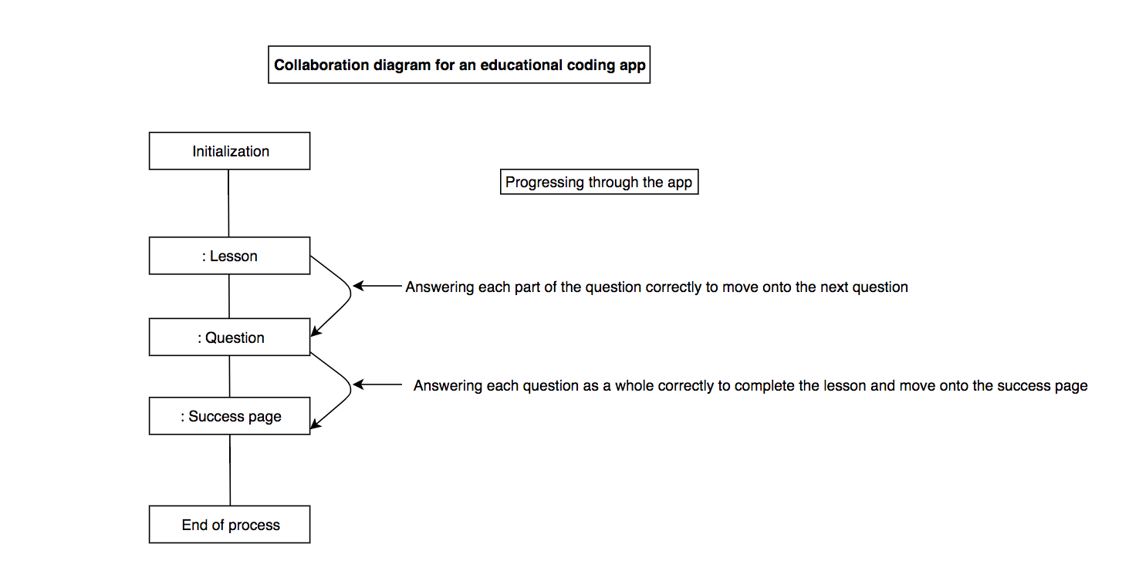

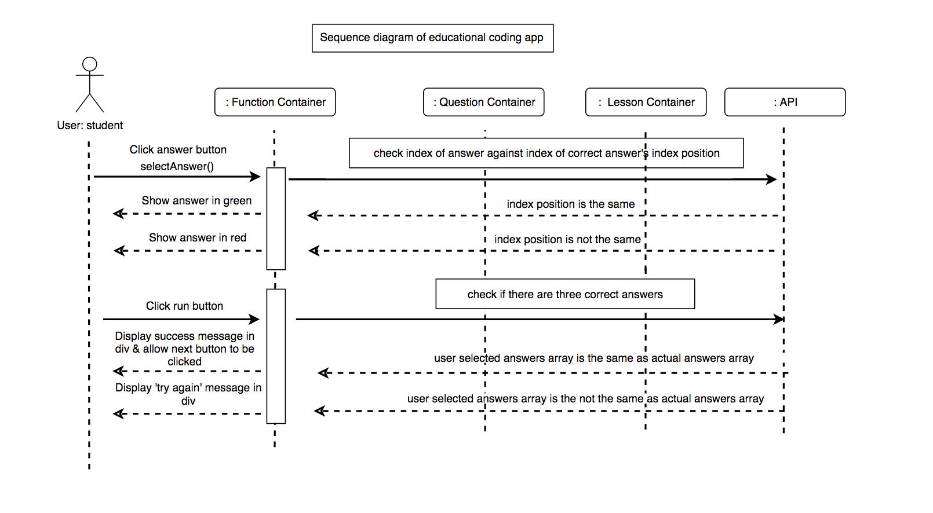

**Description here**

Here is a collaboration diagram and a sequence diagram which shows what happens when you go through the stages of the app and what happens when you interact with a single question on a lesson page.

|  |  |  |  |
| --- | --- | --- | --- |
| **Unit** | **Ref** | **Evidence** |  |
| **P** | P.8 | Produce two object diagrams. | |

**Paste Screenshot here**

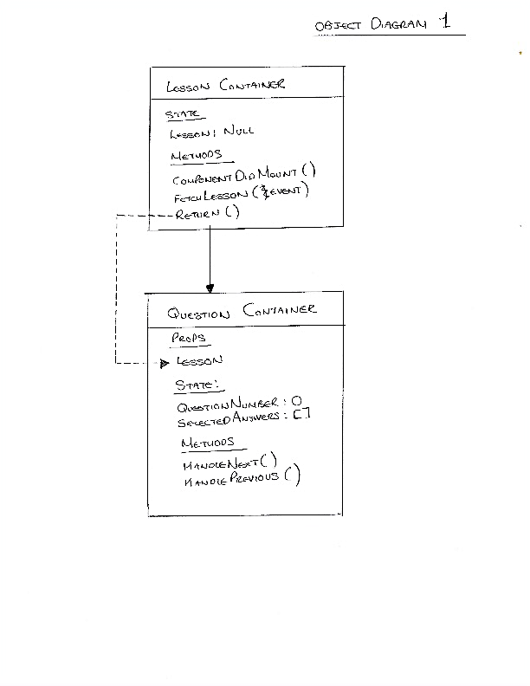

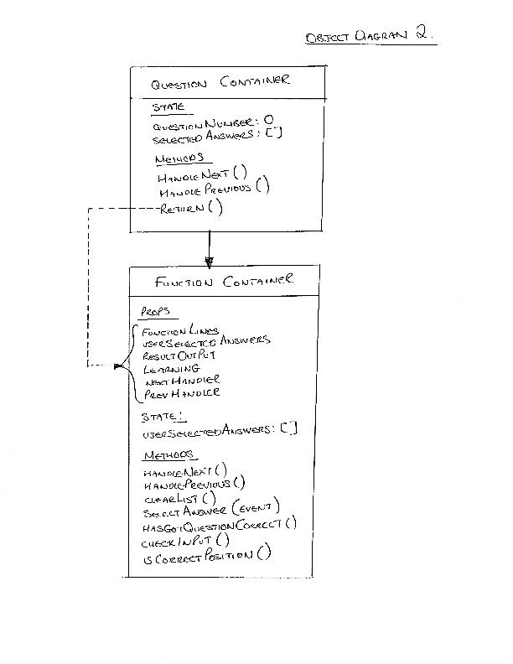

**Description here**

These are two object diagrams for our educational coding app. The first shows the relationship between the lesson container and the question container, the second shows the relationship between the question container and the function container.

|  |  |  |  |
| --- | --- | --- | --- |
| **Unit** | **Ref** | **Evidence** |  |
| **P** | P.17 | Produce a bug tracking report | |

**Paste Screenshot here**

**Description here**